Year 9 Physics Exam Preparation

Use this table to help you revise. Use the web pages linked to the QR codes to revise a topic and then answer the questions to the right. There are more questions on Educake and other resources on the school website.
It will help to use Y7 & Y8 resources too as questions can be based on any topic in Key Stage 3!

Topic | R | A | G | QR code |  | Facts I Need to Know
Earth and Space |  |  |  |  |  | - Why do we have different seasons?  - Draw the magnetic field around the Earth.  - What are the differences between mass and weight?  - What are artificial satellites used for?  - What are the differences between comets and asteroids?
Forces Fields and Electromagnets |  |  |  |  |  | - What does the gravitational field around the Earth look like?  - What is happening inside a wire when an electric current flows?  - What is the effect of increasing resistance on the current?  - What do you need to measure to calculate the resistance of a piece of wire?  - How do you build an electromagnet?  - Where are electric motors used?
Energy |  |  |  |  |  | - What does the Law of Conservation of Energy tell us?  - What does a Sankey diagram show?  - Why is trapped air such a good insulator?  - What are kinetic and gravitational potential energy stores?  - What are the advantages and disadvantages of renewable energy resources?
Motion |  |  |  | 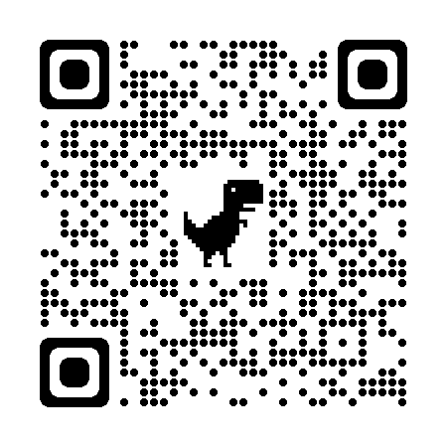 |  | - What is the difference between a vector and a scalar?  - What is the equation to calculate average speed?  - What does a horizontal line represent on a distance-time graph?  - What does a positive linear relationship represent on a distance-time graph?

