States of matter and separating substances

Lesson sequence
- States of matter
- Mixtures
- Filtration and crystallisation
- Paper chromatography
- Distillation
- Core practical – investigating inks (CP7)
- Drinking water

1. States of matter
*Particle | The tiny pieces that all matter is made from.
*Atom | The smallest independent particle. Everything is made of atoms.
*Molecule | A particle made from two or more atoms bonded together.
*State of matter | Whether a substance is solid, liquid or gas.
*Particle model | A theory that uses the idea of particles to explain the differences between solids, liquids and gases.
*Solid | Particle arrangement: Regular pattern, touching each other.  Particle movement: Vibrating around a fixed point.
*Liquid | Particle arrangement: Random, touching each other.  Particle movement: Moving around
*Gas | Particle arrangement: Random  Particle movement: Moving quickly
*State changes | Solid to liquid = melting  Liquid to solid = freezing  Liquid to gas = evaporating or boiling  Gas to liquid = condensation  Solid to gas = sublimation  Gas to solid = deposition
**Heating curve for a pure substance | Temperature rises as you heat a solid, levels out as it melts, continues rising once fully liquid, levels out whilst boiling and rises again once fully gas.
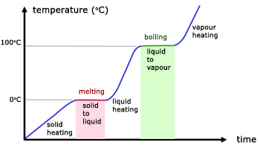

2. Mixtures
*Element | A substance made from only one type of atom.
*Compound | A substance made from two of more different elements bonded together.
*Mixture | A substance made of two of more substances (elements or compounds) mixed but not bonded together.
**Melting point of mixtures | Mixtures do not melt at a fixed temperature but melt gradually over a range of temperatures.
**Heating curves of mixtures | The flat sections of the heating curves of a pure substance are sloped for a mixture.

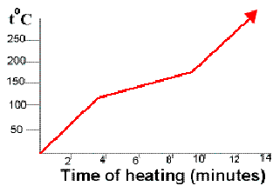

3. Filtration and crystallisation
*Dissolve | When a substance mixes with a liquid by breaking down into individual particles (atoms or molecules).
*Soluble | When a substance can be dissolved by a liquid.
*Insoluble | When a substance can’t be dissolved by a liquid.
*Filtration | A method of separating a mixture of a liquid and an insoluble solid by passing it through a filter paper.
**Residue | The solid that gets left behind in the filter paper.
**Filtrate | The liquid that passes through the filter paper.
**How filtration works | The filter paper contains many tiny holes. The water molecules are small enough to pass through the holes, the solid particles are too big and get trapped.
*Solution | A mixture of a solute dissolved in a solvent.
**Solvent | A liquid that has dissolved a substance, for example water.
**Solute | A solid that has been dissolved, for example salt.
*Crystallisation | A method of collecting the dissolved solid from a solution by heating it so that the solvent evaporates away.
**Risks of crystallisation | As the solvent boils away, the hot solution can spit, so you should wear safety goggles to protect your eyes.
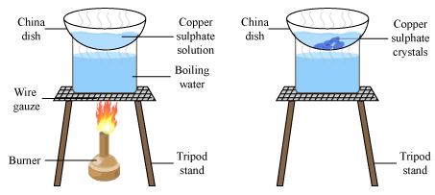

4. Paper chromatography
*Paper chromatography | A method of separating out mixtures of liquids to show what is in them, by letting them travel up a piece of chromatography paper.
*Chromatography method | 1. Draw pencil line on paper  2. Place sample spot on line  3. Place paper in solvent, with solvent below pencil line.  4. Allow solvent to soak up the paper  5. Stop when solvent near top, and mark how far it gets.
**Stationary phase | The substance the solvent moves through – usually paper (Note: technically it is a thin layer of water from air that is bound to the paper molecules)
**Mobile phase | The solvent.
**R_{f} (retardation factor) | R_{f} = spot distance / solvent distance
**Uses of R_{f} | R_{f} enables you to identify a substance because for a given solvent and stationary phases, it is unique to each substance.
**Uses of chromatography | - To tell between pure and impure substances  - To identify substances by comparison with known ones  - To identify substances by calculating R_{f}.
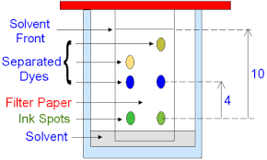

5. Distillation
*Distillation | A method used to collect pure liquid from a solution, such as getting pure water from seawater.
**Condenser | A glass tube surrounded by a glass jacket containing cold tap water. Used to condense gases back to liquids.
**How distillation works | The solution is heated until it is hot enough for the solvent to boil. The solvent is then passed through a cool condenser where it turns back to liquid. The solute does not get hot enough to evaporate and stays where it is.
**Anti-bumping granules | Jagged grains of glass that are added during distillation to prevent violent boiling.
*Fractional distillation | A type of distillation used to separate mixtures of two or more liquids.
**How fractional distillation works | The liquid with the lowest boiling point boils first and can be collected, then the next boils and so on.
**Fractionating column | A tall glass column used during fractional distillation that gives a better separation of the liquids by producing a temperature gradient.
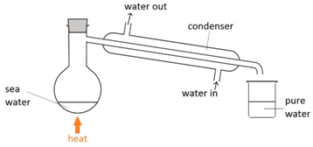
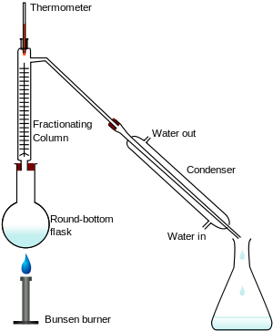
6. Practical – investigating inks
Aim | To separate inks using distillation and chromatography.
Distillation set up | Place some ink in a conical flask with a side arm and delivery tube attached, place the flask on a tripod above a Bunsen burner. Place a boiling tube in a beaker of ice and place the delivery tube into the boiling tube.
Run the distillation | Light the Bunsen burner and allow the ink to boil, stop once a few drops of liquid have collected.
Distillation results | Pure water collects in the test tube because it boils and the cold ice condenses the vapours back to liquid. The ink gets darker because there is less water to dilute it.
*Chromatography setup | 1. Draw pencil line on paper  2. Place ink spot on line  3. Place paper in solvent, with solvent below pencil line.  4. Allow solvent to soak up the paper  5. Stop when solvent near top, and mark how far it gets.
Chromatography - calculate Rf | Measure how far each of your spots has moved from the line and how far the solvent has moved. Rf = spot distance / sample distance.
Chromatography results | The ink separates into multiple different spots. The one that moves furthest is most soluble in the water.
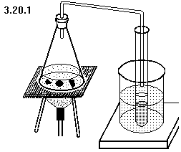
7. Drinking water
*Potable water | Water that is safe to drink.
*Desalination | Producing pure water from seawater.
**Purifying seawater | The seawater is distilled: heating the water to produce water vapour and condensing it back to liquid. Uses lots of energy.
**Uses of pure water | Pure water has to be used when chemists analyse substances to fins out what they contain. Tap water contains many dissolved substances that could interfere with this.
**Water treatment in the UK | Water is passed through a sedimentation tank, to allow sediment to settle out, it is passed through a filtration tower to remove floating particles, chlorine is added to kill bacteria.

