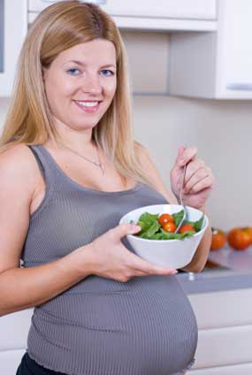
Diet during and just after pregnancy
https://www.nhs.uk/conditions/pregnancy-and-baby/healthy-pregnancy-diet/
https://www.babycentre.co.uk/a3561/diet-for-a-healthy-pregnancy
https://www.nutrition.org.uk/healthyliving/nutritionforpregnancy/nutrition-and-supplements-during-pregnancy.html
- Why should an expectant mother try to increase the amount of fibre she eats?

- Which foods are good sources of protein?

- Why is it recommended that we eat limited amounts of fatty foods?

- What does a shortage of iron cause?

- Why is calcium an essential mineral?

- Vitamin C is essential for healthy skin and gums but what other job does it do?

- Why is folic acid important in an expectant mother’s diet?

- Why should all meat be thoroughly cooked?

- What is the name of the bacteria in eggs which can cause food poisoning?

- Why is good hygiene essential when preparing food?

- Which foods should a new mother avoid to help her lose weight?

- If breast feeding which foods should a new mother avoid?

