New Parent Project
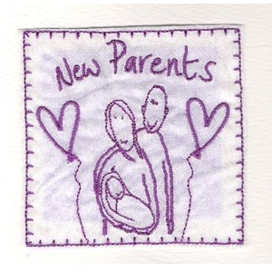

New parents are always in need of information to help them better understand what they are going to experience or what are the best ways to ensure the health of themselves should they wish to start a family or hold off until they are ready for a family.
I would like you to create a booklet, poster or a PowerPoint presentation for new parents. You should use your own words and NOT copy and paste from the internet. Each booklet, poster or PowerPoint presentation must contain the following:

Possible Pts. | Description of Criteria | Points Earned
10 pts | One paragraph stating the purpose of the booklet or PowerPoint Presentation (3-5 sentences) Explain or outline what you are going to showcase.
12 pts. | Contraception: At least 6 different types with description and illustration. (Make sure you tell how this will be beneficial to both the man and the woman). Minimum two sentences for each and use pictures
10 pts | Male/female reproductive system explained with pictures.
15 pts | What should a man and woman do to ensure they are in peak condition for pregnancy.
10 pts | What problems from both could stop or slow the woman from getting pregnant
10 pts | Explain why STI’s AIDS and/or genetics can cause problems with pregnancy and should be considered before getting pregnant. Give examples
10 pts | A list of useful websites they can use with an explanation for each
10 pts | Explain what a pregnancy test is, where you can buy them, price, explain how it works. Show examples using a mood board or maybe flow chart.
10 pts | Write an evaluation on how you have enjoyed or hated this project and explain your reasons in a minimum of 300 words
3 pts | Cover page: Title, Your Name, Date and Class, colours, pictures and presentation
100 pts | Total Points

G Theobald March 2020

