Revision Overview for Y7 Exam.
- List the four conditions germs and bacteria need in order to grow.
- T
- M
- F
- W

- Complete the sentence below by filling in the missing words:

When germs and bacteria are transferred from one place to another, this is called c…………. c………………………. To stop this from happening we must always w…………….. our hands before handling food. We must also wear an a………… to stop the germs on our clothes transferring onto food.

- Name the pieces of equipment in the table below and give one example of what they are used for.
Equipment | Use
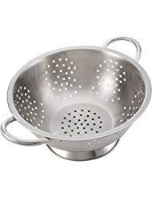
Name of equipment

………………………………..
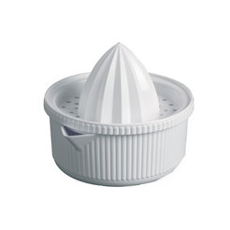
Name of equipment

………………………………..
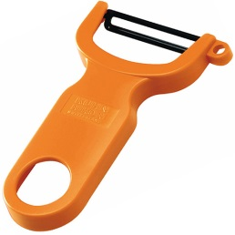
Name of equipment

………………………………..

- How many fruits and vegetables should we aim to eat each day?
…………………………………………………………………………………………………………………………………………………..

- Name the 2 knife skills we use when preparing fruits and vegetables.
…………………………………………………………………………………………………………………………………………………..
…………………………………………………………………………………………………………………………………………………..
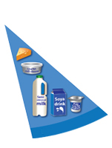
Give the name of the blue section of the Eatwell guide and list 4 products which are found in this section.
Name of the section ……………………………………………………………….. …………………………………………………………………………………………………
4 products which are found in this section:

- Below is a picture of the Eatwell Guide. Create a menu for a day for a teenager that meets the requirements of the Eatwell Guide.
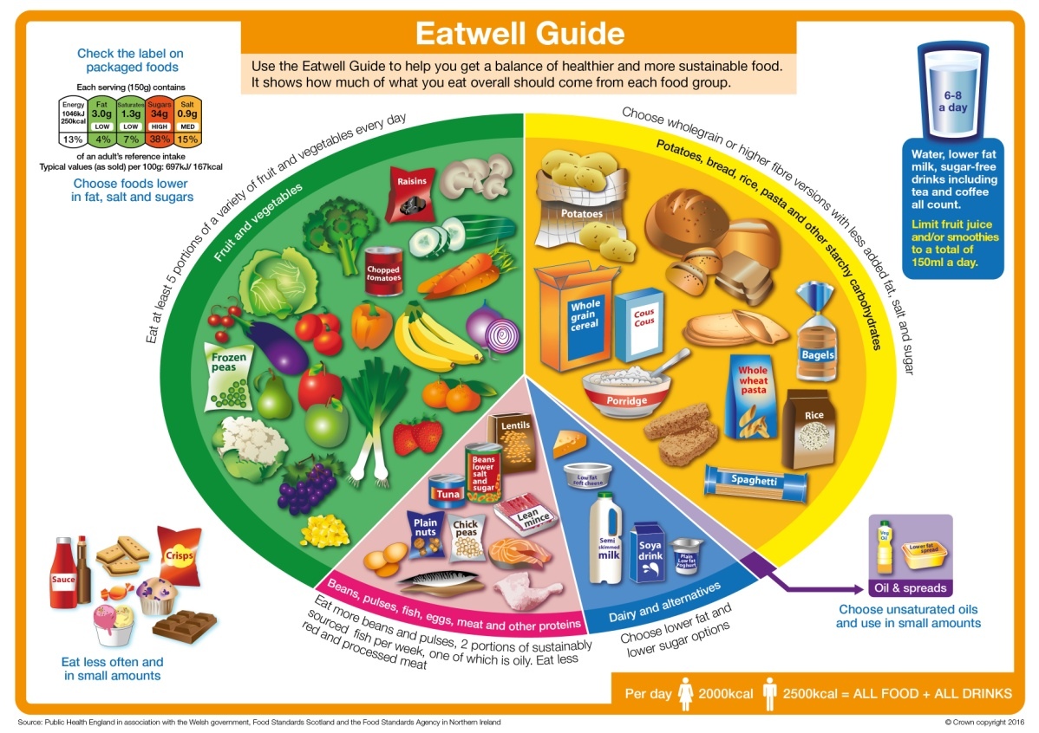

Breakfast:
Lunch:
Dinner:
Snacks/Drinks:

