GCSE Psychology – Paper 1 and paper 2
YEAR 9
Cognition and behaviour
Student revision guide

MEMORY

What you will need to know for the exam:
- Processes of encoding, storage and retrieval
- A study of encoding
- Different types of memory
- The multi-store, including description and evaluation of studies to investigate these explanations of memory
- Primacy and recency effects in recall
- Memory as an active process, Bartlett war of the ghosts and the theory of reconstructive memory
- Factors affecting the accuracy of memory including interference, context and false memories
Encoding (input): changing information so that it can be stored.

Storage: holding information in the memory system.

Retrieval (output): recovering information from storage.

Encoding
Visual encoding: Memories stored visually

Acoustic encoding Memories stored in terms of what they sound like

Semantic encoding Semantic refers to meaning – this is your ability to understand words and concepts
Other encoding: tactile encoding for what things feel like and olfactory for smells

Baddeley – a study into encoding

Aim: To see if there was a difference in the encoding of short term and long term memory.
Method: There were 5 groups of participants. Each was given a list of different words to learn. The words were read out loud to the participant every 5 seconds. After each set of 5 words they were asked to immediately recall them in the correct order. Groups A and B did this. Groups C and D recalled their words after 20 minutes.
Results: Baddeley found participants did worse with list A than B (words below). He also found they did worse with list C than list D.
Conclusion: STM is encoded acoustically as list A had acoustically similar words. Participants got the words muddled up do they must have been thinking in terms of the sounds of the words. List C had semantically similar words (they all have a similar meaning) suggesting that information is encoded semantically if not recalled right away (LTM)
List A: - cat, can, cab, cad, cap etc
List B - pit few cow pen etc
List C - great large big huge broad etc
List D - good huge hot safe thin deep etc
Evaluation of Baddeley
- Lacks ecological validity because memory in real life does not usually consist of remembering lists of words.
- A controlled experiment so the results are valid. The study was in a lab so other variables have less of a chance of effecting the results
- May not have been measuring LTM – he asked them to recall after 20 minutes. Is this LTM? People may not have been able to recall the words the next day so he may not have been testing what he wanted to.

Multi-store Explanation
Sensory store
Long-term memory
Short-term memory

Long-term memory
Short-term memory
Sensory store
EXAM TIP:
When asked to identify a feature (for example, a feature of the multi-store model), this means that you must name it. Then, to describe it, you must say something about that feature.
Duration: Up to a lifetime
Capacity: Unlimited
Coding: Semantic
Duration: less than 30 seconds unless rehearsed
Capacity: Approximately 7 chunks of information 5+/-2
Coding: acoustic
Duration: Less than a second
Capacity: high capacity – all of the 5 senses pass information to it
Coding: depends on sense eyes is visual, ears is acoustic etc.

Evaluation of Multi-store model
- Lacks ecological validity because memory in real life does not usually consist of remembering lists of words.
- Not everything needs to be rehearsed; many everyday events can be easily remembered and many things that are rehearsed are forgotten if you don’t understand them.
- The model is too simple. Research has shown STM is divided into separate visual and acoustic stores making our memory far more complex than this model suggests.
- Baddeley supports the idea that STM and LTM are separate as they are both encoded differently.

Primary and recency effects on recall

Evaluation of Murdock
- Lacks ecological validity because memory in real life does not usually consist of remembering lists of words.
- A controlled experiment so the results are valid. The study was in a lab so other variables have less of a chance of affecting the results. IV and DV are controlled
- Research has shown people with amnesia can’t store long term memories and also do not show a primacy effect but they do show a recency effect confirming that primacy effect is linked to LTM.
Murdock (1962)
Aim: To see if memory of word was affected by the amount of words you have to remember
Method: Murdock randomly selected 4000 words from the most common words in English. 103 students on a psychology course took part in the study. They took part in a number of different sessions. In each session they listened to 20 word lists, each containing different words. The words varied in length from 10 to 40 words. After each list the pp had to recall the words they had just heard.
Results: The words at the end of the list were recalled first (known as the recency effect). Words from the beginning of the list were also recalled quite well (known as the primacy effect), but the middle words were not recalled very well at all.
Conclusion: Murdock concluded that this provides evidence for separate short-term and long-term store as the words they heard first had been rehearsed so had passed top the LTM store and the most recent words were still in their STM. The position of a word effects how likely it is to be recalled (serial position effect)
Processes: Different types of memory
Long term memory

Episodic memory - Memories from events. What you have done and what experiences you have had. E.g. a gig you went to last week, your birthday party etc. these memories are time stamped.

Semantic memories – It is the meaning of everything you know, knowledge that is shared with others. E.g. Paris is the capital of France, England winning the world cup in 1966. These are not time-stamped.

Procedural memories – muscle memory. Remembering how to do things e.g. ride a bike. We can recall these without conscious awareness or a great deal of effort.

Evaluation of LTM
- Clive Wearing – a case study where he could still play the piano (procedural memory) but had almost all of his past showing different types of memory.
- HM case study also supports this. He had his hippocampus removed and he could recall how to do things but not recall events from the past.
- Research has shown that the different types are in different parts of the brain. Episodic and semantic in the prefrontal cortex (episodic in the left and semantic in the right) procedural has been found in the motor cortex.

Reconstructive Memory

We may reconstruct what we think we saw or processed to help us retrieve it from long-term memory.
Bartlett (1932)
Aim: To see if people, when given something unfamiliar to remember, would alter the information. To use a story from a different culture to see how cultural expectations affect memory
Method: Participants were asked to read a story called ‘The War of the Ghosts’, which was a Native American legend. After 15 minutes they were asked to retell the story as accurately as possible. Then he showed a new version to another participant and asked them to recall it a short time later. This retelling was repeated several times during the weeks that followed.
A key feature of the study was it belonged to a culture that was very different to the pps . His participants were from his university in the UK.
Results: Bartlett discovered that his participants found it difficult to remember bits of the story concerned with spirits and changed other bits of the story so that it made more sense to them. Each time they retold the story they changed it some more.
The story was shortened, phrases were changed to fit the pps own culture e.g. “boats” instead of “canoes”
Conclusion: Bartlett concluded that our memory is influenced by our own beliefs and these beliefs and fragments make the material easier to remember.
EXAM TIP:
When you are asked to describe a study, you must always state the aim of the study, the method used, the results obtained and the conclusion drawn. You must include all four elements in your answer to receive all of the marks.

Evaluation
- It would be very difficult to measure the accuracy of the stories told with a
  - reliable scoring method. – the participants were not given specific details about what they needed to do.

- This study is more relevant to the way we use memories in everyday life, so it has
ecological validity, however, the story was unusual does not reflect everyday processes.

Bartlett interpreted his own data so may have affected the way his behaviour should be interpreted.

The theory of reconstructive memory
Evaluation
  - Bartlett tested memory using specific materials which could test memory in everyday life unlike trigrams and most other memory research. Bartlett is more relevant to real-life memory processes.

Not all memories are inaccurate or affected by social expectations.

This information can be used to explain problems in Eye witness testimony. Bartlett helped to highlight that memories may not be accurate after all.

Effort after meaning – People recalled the general meaning of the events rather than the specific meanings in the War of the ghosts story. Bartlett used the phrase “effort after meaning” to describe this. He meant 1. We focus on the meaning of events and 2. Afterwards we try to interpret the meaning of the events into more familiar fragments.
Memory is inaccurate – Bartlett changed the notion that we can recall any event without altering it in any way. He proposed memory was an active process. We store fragments of information and when we need to recall something we build these fragments into a meaningful whole.
Social and cultural influences – People transform parts of a story or picture based on their cultural expectations. This changes how they recall information. Bartlett called this “the social psychology of remembering”
Reconstruction – We change our information before we store it in our LTM. We “record” small pieces if information and then later, when recalling the event, we recombine the pieces to tell the story.
Accuracy of memory - Interference
Retroactive interference: When information we have recently learnt hinders our ability to recall information learnt previously
Proactive interference: When information we have already learnt hinders our ability to recall new information

Interference: Things that we have learnt that make it difficult to recall other information that we have learnt

Proactive interference

Retroactive interference

McGeoch and McDonald’s study
Aim: To see what affect a second activity has on the accuracy of memory
Method: Participants were asked to learn a list of 10 words until them could remember them with 100% accuracy. They were the shown a new list. 12 participants were used.
There were 5 different lists shown to participants
List 1 – synonyms – words with the same meanings as the originals
List 2 – antonyms – words with the opposite meanings to the originals
List 3 – words unrelated
List 4 – nonsense syllables
List 5 – three-digit numbers
Results: When the participants were asked to recall the original list of words, their performance depended on the nature of the second list. The more similar the material, the less accurate the recall
Conclusion – interference is strongest when an intervening activity is similar.
Evaluation of McGeoch and McDonald
- Lacks ecological validity because memory in real life does not usually consist of remembering lists of words.
- A controlled experiment so the results are valid. The study was in a lab so other variables have less of a chance of affecting the results. IV and DV are controlled
- Not really forgetting – It is possible that interference effects are just temporary and that the information is not actually forgotten.

Accuracy of memory - Context
Godden and Baddeley (1975)
Aim: To see if people who learn and are tested in the same environment will recall more information than those who learn and are tested in different environments.
Method: 18 Participants who were deep-sea divers were recruited. They were divided into four groups. They were given 36 unrelated words either on a beach or under 10 feet of water. All of the groups were given the same list of words to learn:
- Group 1 had to learn underwater and recall underwater
- Group 2: had to learn underwater and recall on the shore
- Group 3 had to learn on the shore and recall on the shore
- Group 4 had to learn on the shore and recall underwater
Results: Groups 1 and 3 recalled 40% more words than groups 2 and 4.
Conclusion: Recall of information will be better if it happens in the same context that learning takes place.
Group 1
Learn Recall
Group 2
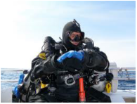
Learn Recall
Group 3
Learn Recall
Group 4

Evaluation of Godden and Baddeley
- Lacks ecological validity because memory in real life does not usually consist of remembering lists of words.
- The recall was short-term. If we want to study the effect the context really has they should have asked them to recall the information later on.
- The context of being underwater is not realistic – in reality the information people need to know for an exam is usually learnt in multiple contexts and is not affected by one specific context.

Accuracy of memory: False memories
Loftus & Pickrell
Aim: To see if false memories could be created in pps through suggestion in order to test the existence of repressed and false memories
Method: There were 24 participants in the study. A relative was also contacted for each pp. The pps were given 4 short stories about childhood events that had been obtained from their relatives. Three of the stories were true and one was false. The false story was about getting lost in a shopping mall in their childhood and being rescued by an elderly woman. The false information was crafted from the information given by the relative e.g. the relative said what the child’s favourite story was etc. Each child was asked to read each story and write down what they remembered about each event. A week or 2 later they were interviewed about the stories. They were interviewed a second time and then debriefed.
Results: IN total there were 72 true episodes to be remembered and pps remembered 68% of these. 6 of the pps (25%) recalled the false story fully or partially. 19/24 participants correctly guessed the lost in the mall memory as false.
Conclusion: The research suggests that the mere act of imagining the event has the potential to create and implant a false memory in a person. This affects the accuracy of memory.
Evaluation

- Lacks ecological validity because memory in real life does not usually consist of remembering stories – the story about a mall is not a traumatic event so may affect the results
- Ethical; issue – pps may be left with implanted memories. Even though they did a debrief at the end people may be left or have lingering sense that it happened. This is manipulation.
- Had real life application for eye witness testimony. Such research into leading questions and false e memories has changed the way courts deal with EWT – it is no longer regarded as being a reliable.

SOCIAL INFLUENCE (PAPER 2 MATERIAL)

What’s in this unit?
You need to be able to do the following for the exam-
- Define conformity, obedience, social loafing and deindividuation
- Describe and evaluate studies into conformity, obedience, social loafing and deindividuation
- Explain dispositional and situational factors affecting conformity, obedience, social loafing and deindividuation
- Crowd and collective behaviour
- Explain factors affecting bystander intervention
- Describe and evaluate key studies Pilavin,and Asch

Conformity-
This is a change in a person’s behaviour or opinions as a result of group behaviour.

Asch (1951) KEY STUDY
Aim | To find out if an individual would conform to the group even when they knew the group was wrong.
Method | Solomon Asch devised a number of lab experiments with groups of 6 to 9 people (all male college students). There was one naïve participant and the rest were confederates who had been told to give the wrong answers on certain trials. The task was for participants to judge the length of lines (they were told that it was a test of visual perception). Asch showed the group lines of different lengths and asked them to match the test line to one of the comparison lines. The participant was the last to give their answer.
Results | In control group trials, when participants were tested alone, there were very few wrong answers. However, in a group, 25% of the participants conformed to the group most of the time when the group was wrong. 75% of participants conformed to the group when they were wrong at least once.
Conclusion | 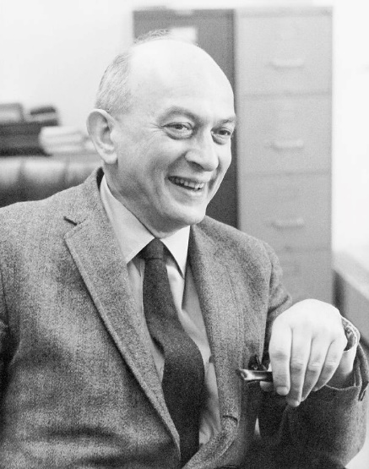  People will conform to the group even when they know the group is wrong in order to avoid ridicule.

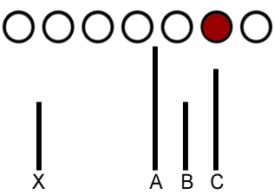

What are the strengths and weaknesses of this study?
Evaluation-
+ The research method used was a lab experiment. This means that Asch could confidently conclude that the set-up was directly affecting the conformity rates.
+ The task was not ambiguous. This means that there was a definite answer and the result was easy to measure.
- The study lacks ecological validity. People are not asked to judge the lengths of lines, in groups, in everyday situations.
- There are ethical issues. The participants were not only deceived about the aims of the test, but were also placed under psychological stress.

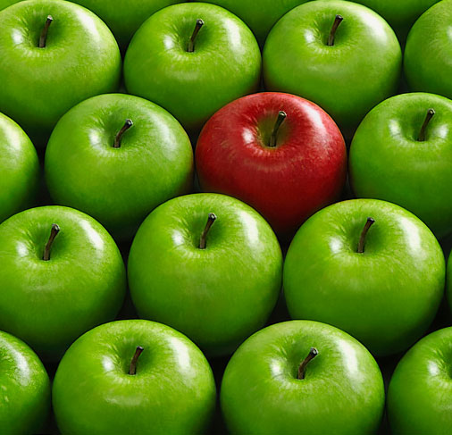
What factors affect conformity? - Situational
Studies have revealed that there are 4 main factors which affect conformity-
- Size of group- the larger the group size, the more likely people are to conform.
- Others agreeing with the pp- if individuals in the group perceive others in the group to be of a higher status than themselves, they are more likely to conform.
- Task difficulty- the more difficult a task is perceived to be, the more likely we are to conform with others completing the same task.
- Culture- Individuals from collectivist cultures are more likely to conform than those from individualistic ones.

What factors affect conformity? Dispositional

LOCUS OF CONTROL – An external locus of control is where someone believes in luck and fate and do not believe they have control in life. This type of locus of control is more likely to conform in society.

EXPERTISE – Experience increases your confidence in a particular area. If you are more experienced you are less likely to conform in a group situation.
Obedience-
Obedience means following the orders of someone we believe to be in authority.

What factors affect obedience?
- Environment or setting- if an individual is in a ‘formal’ environment such as a workplace or a place such as a doctor’s or dentist’s waiting room, then they are more likely to follow instructions.
- Culture- as with factors affecting conformity, the type of culture a person originates from has a major impact on whether someone is likely to obey. Again, people from collectivist cultures are more likely to be unquestioningly obedient.
- Proximity - when the subject and authority figure are close, this is likely to increase the likelihood of obedient behaviour.
- Authority figure- not only is it important the authority figure is close, but also the extent to which the authority figure has the power to punish is an important factor.
What studies have been carried out into obedience?

Hofling et al (1966)
Aim | To seem if people would follow an unreasonable order in their normal work environment.
Method | Hofling contacted 22 senior psychiatric nurses individually by phone. Claiming to be a doctor, he instructed them to give a patient twice the maximum dosage of a drug called Astrofen.
Results | Of the 22, 21 nurses were prepared to follow his order, despite the fact that the correct dosage was recorded on the bottle, the orders were given late at night (which was against hospital policy), and had also been given over the phone (again against hospital policy).
Conclusion | Hofling showed that in real-life situations, people are willing to be follow instructions even when they believe that they wouldn’t do this.

What are the strengths and weaknesses of this study?
Evaluation-
+ This study has some level of ecological validity. That is, as the situation was “real” Hofling et al could demonstrate that their findings do relate to real-life nurse behaviours.
- The fact that Hofling conducted a field experiment may have led to the procedure to be effected by extraneous variables. For example, the hospital being particularly busy on the night in question.
- Ethical issues. The nurses were placed under psychological stress and informed consent was not obtained.

- Describe and evaluate one study in which obedience was investigated. Include in your study, the methods used, the results obtained and the conclusion drawn. Evaluate the study you have described. (Answer in continuous prose.) (6)

Milgram
Aim | To investigate in certain circumstances whether a normal person would give someone a potentially lethal electric shock if told to by an authority figure.
Method | Recruited 40 volunteers from the New Haven area, aged 20 – 50.  They were paid $4.50 to take part and were the real participant. They net a confederate “Mr Wallace and the experimenter and drew lots for their role.  The teacher had to read word pairs out to the learner in the other room and every time they got the word pair wrong they would be given a shock.  If the teacher asked for guidance they were told to continue.
Results | 65% went to the maximum voltage  100% went to 300 volts
Conclusion | People were willing to obey an authority figure even if it meant killing someone. Other factors such as location and proximity also had an effect.  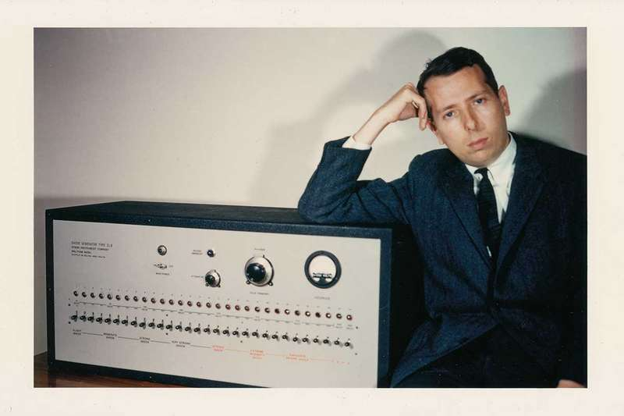  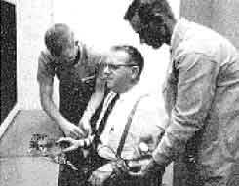

Evaluation-
- The study lacked realism, some have suggested that the pps may have guessed that the shocks were not real and continued due to this.
- Sheridan and King support this study – women and men shocked the puppy when ordered to do so by an authority figure.
- There a number of different ethical issues – 3 people had full blown seizures during the study due to stress. They were not given the right to withdraw and full informed consent.

Milgram’s Agency theory
Milgram believed that if you were acting on behalf of someone else you would be more likely to obey. He believed this as you are acting as an agent for them and that the responsibility of what happens to that person is with someone else and not down to you. (Agentic state)
If you are in the autonomous state – you would take responsibility for your actions and behave according to your own principles.

AUTHORITARIAN PERSONALITY – some people have an exaggerated respect for authority, they are far more likely to obey authority and they look down on people with an inferior social status.
People with this personality type have usually had a harsh upbringing and often see things as being “black or white” – something is either good or bad.
Evaluation – based on a questionnaire so they could have lied to make themselves appear better than they are. Also, the results are correlational so you cannot establish cause and effect (there could be other reasons why someone may obey and not necessarily because of this personality type.

Piliavin (1969) KEY STUDY
Aim | To test how bystanders behaved when put in a situation where a ‘victim’ needed help.
Method | Field experiment on New York subway trains.  Male confederates would either act drunk or blind and then pretend to fall on the ground.  Two observers recorded how many people went to help the ‘victim’.
Results | - The blind victim received more help than the drunk victim  - Victims were more likely to be helped by someone of the same race.  - The victim was more likely to be helped by males.
Conclusion | The appearance of the victim affected whether they received help- this could explain why more people helped the blind victim compared to the drunk victim. T  he cost of helping may be a factor affecting bystander intervention. If the costs of helping are low the bystander is more likely to help.

What are the strengths and weaknesses of this study?
Evaluation-
- This study has been criticised for being unethical. The participants were deceived as they believed the victim and fall was genuine. Additionally, they may have experienced psychological harm such as distress when witnessing the incident and/or guilt/embarrassment for not helping the victim.
+ This study was a field experiment so it was high in ecological validity- this means the situation was reflective of real life and therefore the participants behaviours were natural and results were valid.

Prosocial behaviour – factors that influence whether someone will help or not. This term refers to the likelihood of people in the vicinity of an incident choosing to become involved and attempts to explain why some individuals choose not to become involved in certain situations. There are several factors we need to consider-
- Diffusion of Responsibility-
This is when each bystander takes no action, because of a lack of knowledge, and this misleads the others into defining the incident as a non-emergency. (Expertise)

Latane & Darley (1968)
Aim | To test the concept of diffusion of responsibility.
Method | They tested this concept by asking students to sit in booths and communicate with each other via an intercom. They had a number of different conditions, which were as follows-  - The participant believed that there was only one other person in the booth.  - The participant believed that there were two other people in the booths.  - The participant believed that there were five other people in the booth.  After the discussion had started, one of the others (a confederate) mentioned that he was epileptic. After a few minutes he pretended that he was having a seizure.
Results | Condition % who responded in 4 minutes  Condition 1 85%  Condition 2 62%  Condition 3 31%
Conclusion | The results support the view that as the number of bystanders increase, the less chance the victim has of receiving help. This is an example of diffusion of responsibility.

What are the strengths and weaknesses of this study?
Evaluation-
- Latane & Darley only used male participants as their sample. This may make it difficult to generalise to female behaviour or the behaviour of females outside of America.
- Ethical issues: Participants may have been placed under unnecessary psychological stress during the procedure.
+ Latane & Darley could be confident that it was the group size that affected the amount of bystander intervention that happened.

- Presence of others – This is the idea that the more bystanders present, the less likely that the victim or the subject needing aid is likely to be helped. This factor was studied by Latane & Darley (1968)-
Latane & Darley (1968)
Aim | To test the concept of pluralistic ignorance.
Method | There were two conditions-  - Participants were asked to sit alone in a room in order to complete a questionnaire. Smoke (actually steam) was pumped into the room. The participants were timed as to how long it took them to report the smoke. The experiment was stopped after 6 minutes.  - The 2nd condition was the same as the first, except that the participant was in the room with 2 confederates. When the participant asked the other two what they thought was happening, their response was, “dunno”.
Results | 75% of the participants reported the smoke within the 6 minutes when they were alone compared to only 10% of those participants in condition 2.
Conclusion | This study proved that people don’t want to overact in the presence of others and will follow what others do even when this is nothing.

What are the strengths and weaknesses of this study?

Cost of helping – Research has suggested that person’s decision to help in a situation is based on the cost – reward model. Cost of helping can include possible danger to yourself, the effort that will need to be made the time it will take or possible embarrassment. Also, the cost of not helping can be taken into account as well e.g. feeling guilty for leaving someone in need of help.

Similarity to victim – Research has suggested that people are more likely to help someone who has a similar characteristic to themselves. This could be ethnicity or something in common. Research into football fans found that football fans were more likely to help someone who has fallen over if they support the same football team as them compared to a rivals team.
Deindividuation-

This is the state of losing our sense of individuality and becoming less aware of our own responsibility for our actions.

What are the factors that affect deindividuation?
- The mood of the crowd- when people are in a crowd they tend to pick up the mood and respond to it (for example, football hooliganism might be explained in this way). It can also have a positive effect (for example, people dancing at a concert.
- Anonymity- this is supported by research. If participants are difficult to identify, they are more likely to engage in anti-social behaviour. Therefore, wearing a mask, being in a large group, being in the dark and even wearing a uniform all contribute to anonymity.
Zimbardo et al (1969)
Aim | To test the idea of deindividuation.
Method | Using female participants in groups of four, participants had to give electric shocks to Zimbardo’s confederates. The participants were told that they were taking part in a learning exercise. There were two conditions: in one the women wore hoods and identical coats (so that they were anonymous); in the other they wore their own clothes with name tags on and spoke to each other using their own names.
Results | Zimbardo found that the anonymous women were twice as likely to give shocks compared with the women wearing their own clothes.
Conclusion | Zimbardo concluded that if people know that they cannot be identified (have anonymity) they are more likely to behave aggressively.
What studies have been carried out into deindividuation?
Evaluation-
- This experiment lacks ecological validity as people are not asked to electrocute people everyday; especially wearing hoods and coats. The results here can therefore not be generalised to other people, places and settings.
- The participants may have experienced distress as they were not aware that the individuals they were administering electric shocks to were confederates. There was also a high level of deception.
+ The method (a lab experiment), means that there was a high level of control of the variables and the study is therefore reliable.

Crowd and collective behaviour
Social loafing-
This is when an individual puts less effort into completing an activity because they are with others who are doing the same things.

What factors affect “social loafing”?
- Size of group- the bigger the group, the more likely social loafing is to occur
- The nature of the task- this refers not only the difficulty of the task but also refers to the interest that someone has in the subject of the task
- Culture- individuals from collectivist cultures are less likely to socially loaf.
What studies have been carried out into “social loafing”?
Latane et al (1979)
Aim | To see whether being in a group would have an effect on how much effort participants put into a task.
Method | 84 male students were asked to clap or cheer as loudly as they could. While they were alone and then when they were in a group of up to 6. Each participant wore headphones so they couldn’t hear the others.
Results | The amount of noise produced by the students decreased sharply as the number of students in the group increased.
Conclusion | People put less effort into doing something when they know others are contributing effort into the same task. These findings support the idea of social loafing.

Culture – People in individualistic cultures such as the UK and USA are focused on individual needs. Collectivist cultures make decisions which are focused on the needs of the group, families and society in general. It makes sense that social loafing is likely to be lower in a collectivist society than an individual one.

Personality – Locus of control – Those who have an internal locus of control are less likely to be influenced by a crowd and collectivist behaviour

Morality – Morals are our ideas of right or wrong. Some people have greater moral strength which means that they have certain principles of right or wrong and are more willing to be guided by these principles. This means that people with high moral strength will be less affected by the social norm created by the crowd.
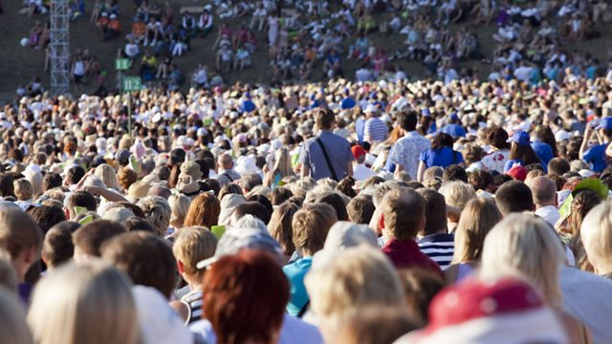

Research method checklist
Content | Additional information
Variables | Independent variable, dependent variable, confounding or extraneous variables
Hypothesis | Directional or non-directional
Quantitative and qualitative data | Know each type of data and specify the difference between the two types. Strengths and weaknesses of each type.
Primary and secondary data | Know each type of data and specify the difference between the two types. Strengths and weaknesses of each type.
Laboratory and field experiments | Strengths and weaknesses of each type
Sampling | Opportunity sampling  Random sampling  Systematic sampling  Stratified sampling
Experimental design | Independent groups  Repeated measures  Matched pairs
Ethical issues | Informed consent  Deception  Protection from harm  Privacy  Confidentiality  AND ways to deal with them
Interviews and questionnaires | Structured, semi-structured and unstructured interviews.  Open and closed questions
Descriptive statistics | Mean, median, mode and range. Strengths and weaknesses of using each type.

