NCFE VCert Level 2 Food and Cookery

Unit 3 – Exploring Balanced Diets (external assessment exam)
Revision Booklet 1

Name…………………………………………………………………………
Date of exam Tuesday 6th November 2018. Duration of exam: 2 hours.
1.1 The learner can explain what is meant by a balanced diet.

Task 1: Fill in the blanks: A healthy balanced diet includes eating a variety of food from the……………………………..…….; including at least 5 fruit and vegetables, plenty of starchy foods such as wholemeal bread, …………………. and rice, some protein rich foods such as meat, fish, ……………………….. and lentils and some dairy foods. A balanced diet should also be low in fat (especially …………………………….) salt and sugar. We should try to make sure we consume foods high in fibre as well as aiming to drink at least 2 litres of water a day.
Eatwell guide pasta eggs saturated fat water
USING THE ANSWER ABOVE ALONE WILL NOT ACHIEVE A PASS!
Complete the following tasks in order to be able to create an answer which will help you to achieve a pass/merit/distinction.
To get a Pass: You need to state all of the nutrients needed and explain their functions, foods where they are found and how they must be eaten in the correct proportion.
Task: Match up the 5 main nutrients to their functions (jobs they do in the body) and then fill in the blank boxes to show which foods which contain these.
 |  | Protein |  | For energy
 |  | Fat |  | To help keep our bones strong and healthy and help the formation of red blood cells.
 |  | Carbohydrates |  | Needed in small amounts for healthy skin, good eyesight etc.
 |  | Vitamins  (A,B,C,D) |  | For growth and repair (can also provide some energy)
 |  | Minerals  (Calcium, iron) |  | To keep us warm and gives us some energy.
Which nutrient do we need in large amounts of and why?
………………………………………………………………………………………………………………………………………………………………………………………………………………………………………………
Which nutrients do we need in small amounts and why? ………………………………………………………………………………………………………………………………………………………………………………………………………………………………………………
To get a Merit: You need to state all of the nutrients needed (including Water and NSP) needed and explain their functions, foods where they are found and explain how they must be eaten in the correct proportion, making reference to some of the RI (reference intakes).
Complete this sentence: Water is needed to keep us h……………... . We lose water every day through our tear ducts, sweat, u………………. and saliva. Water also helps to flush out any toxins in our bodies and helps to deliver the n……………….. from our foods to the different parts of our bodies where they are needed.
Can you list 4 foods/drinks which naturally contain water: ……………………………………………………………………………………………………………………………………………………
NSP (non-starch polysaccharide) or otherwise known as Dietary Fibre is not a nutrient but is still essential. It does NOT provide any energy as the body cannot digest it, however it helps the body to break down other food eaten and helps it to move through our bodies so that we can pass it easily and prevent constipation!
Can you list 4 foods which contain fibre?: …………………………………………………………………………………………………………………………………………………………………
This table shows the Reference Intakes (RI) for each nutrient:
- Reference Intakes (RIs) are used on nutrition labels on packaged food.
- Reference intakes are set by European law, as a guide for the amount of energy and key nutrients that can be eaten on a daily basis in order to maintain a healthy diet.
- The values are maximum amounts based on an average female adult. They are not individual recommendations and your needs may well be different to the RI, depending on your age, gender and how physically active you are.
- There are currently no RIs that can be used specifically for children.
- Food labels show the percentage of the RIs that is provided per 100 g/100 ml and/or per portion of the food item.

DON’T FORGET! The amount we need of each nutrient can be affected by the following factors:
- Age - e.g. the RI for vitamin C for a child aged 1 year and under is 25 mg and for an adult is 40 mg.
- Gender - e.g. the RI for iron in women aged 19-50 years is higher than for men to cover the blood lost during periods.
- Growth - e.g. teenagers have higher calcium requirements to cover their bone growth
- Pregnancy - e.g. The RI for calcium in women that are pregnant or breastfeeding is more than adult females who are not pregnant or breastfeeding.
Recommended daily intake of Dietary Fibre (NSP)

To get a Distinction: You need to state all of the nutrients needed (including Water and NSP) needed and explain their functions, foods where they are found and explain how they must be eaten in the correct proportion, making reference to a variety of RI (reference intakes) including fat, saturated fat, salt and sugar.
This table shows how much Carbohydrate, Fat/Saturated fat and Sugar should make up our energy intake as a %.

- Total carbohydrate includes all starch, sugars and dietary fibre.
- Free sugars are sugars added to foods and drinks by the manufacturer, cook or consumer, plus sugars naturally present in honey, syrups and fruit juice.
- Total fat includes all saturated and unsaturated fat (mono-and polyunsaturated).
- Saturated fat - Several studies have shown a high saturated fat intake to be linked with high blood cholesterol. Elevated blood cholesterol is a risk factor for coronary heart disease. Studies have shown that replacing saturated fat with unsaturated fat in the diet reduces blood cholesterol and lowers the risk of heart disease and stroke.
- On average in the UK we currently eat too much saturated fat and added sugar, but not enough fibre.

This table shows the maximum Salt intake for a day depending on age group:

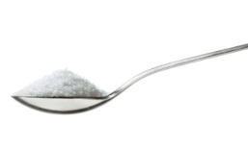

Think of it like this – 6g is a 1 heaped teaspoon of salt!

P M D
Task: Answer the mock exam question below. Circle/highlight in the box if you are aiming for a Pass, Merit or Distinction with this answer.
1a. Explain the meaning of the term “balanced diet”, giving examples where appropriate.
………………………………………………………………………………………………………………………………………………………………………………………………………………………………………………………………………………………………………………………………………………………………………………………………………………………………………………………………………………………………………………………………………………………………………………………………………………………………………………………………………………………………………………………………………………………………………………………………………………………………………………………………………………………………………………………………………………………………………………………………………………………………………………………………………………………………………………………………………………………………………………………………………………………………………………………………………………………………………………………………………………………………………………………………………………………………………………………………………………………………………………………………………………………………………………………………………………………………………………………………………………………………………………………………………………………………………………………………………………………………………………………………………………………………………………………………………………………………………………………………………………………………………………………………………………………………………………………………………………………………………………………………………………………………………………………………………………………………………………………………………………………………………………………………………………………

1.2 The learner can describe the nutrients that make up a balanced diet.

To get a Pass: You need to state the macro and micro nutrients and explain at least 2 of their functions (jobs in the body), 2 sources (foods) where they are found and one effect it can have on the body if we don’t have enough of each nutrient.
To get a Merit: You need to state the macro and micro nutrients and explain at least 2 of their functions (jobs in the body) in detail, 3 sources (foods) where they are found and 2 effects (explained in detail) it can have on the body if we don’t have enough of each nutrient.
To get a Distinction: You need to state the macro and micro nutrients and explain at least 2-3 of their functions (jobs in the body) in detail, 3-4 sources (foods) where they are found and 2-3 causes and its affect (explained in detail) it can have on the body if we don’t have enough of each nutrient.
Nutrients are grouped into 2 groups. These are MACRONUTRIENTS and MICRONUTRIENTS.
Task 1: Use p.22-27 to help you complete the sentences below:
Macronutrients are needed in …………………….…………….by the body for our energy and …………………….
The nutrients in this group are:

Micronutrients are needed in …………………………………… by the body to perform a variety of different jobs.
The nutrients in this group are:

Task 2: Complete the table below about the macronutrients and the micronutrients. Use p.9 in this booklet, p22-27 in the textbooks and the internet to help you.
Macronutrients | Sources (foods it is found in) | Function (what job is does in the body) | Effect on our bodies if we don’t have enough of it (deficiency)
Carbohydrates: Starches
Carbohydrates: Sugar
Fibre
N…………………………………….
S……………………………………..
P………………………………………
Fat: Saturated
Fat: Unsaturated
Protein
Alternative (vegetable) proteins
Micronutrients | Sources (foods it is found in) | Function (what job is does in the body) | Effect on our bodies if we don’t have enough of it (deficiency)
Vitamin A
Vitamin B (complex)
Vitamin C
Vitamin D
Calcium (mineral)
Iron (mineral)

Vitamin and Mineral Deficiencies
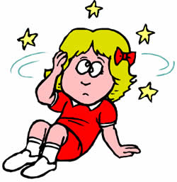
These are some of causes and effects (symptoms) on the body if we don’t get enough of the nutrients we need. (This is called a deficiency).
Iron Deficiency = the most common symptoms of iron deficiency are:
- extreme fatigue (tiredness)
- weakness and dizziness, which signal that many cells throughout the body are struggling without oxygen – this is called Anaemia.
- Pale skin and cold hands and feet indicate a lack of sufficient blood flow.

Vitamin D deficiency = brittle and soft bones, rickets in arms and legs
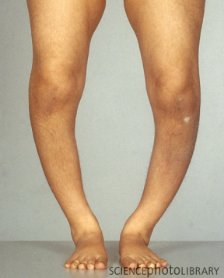
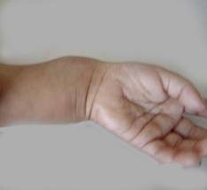

Vitamin A deficiency = poor eye sight, blindness in young children
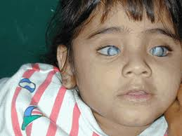
Vitamin B complex deficiency = can cause Anaemia, some other symptoms are:
- a pale yellow tinge to your skin
- a sore and red tongue
- mouth ulcers

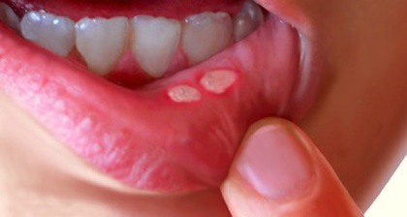
Vitamin C deficiency = muscle/joint pain, Scurvy (bleeding/swelling of gums)
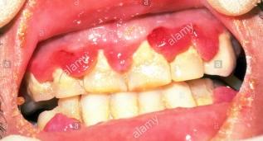
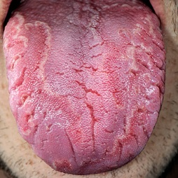

Calcium deficiency = White spots on nails, weak or brittle bones
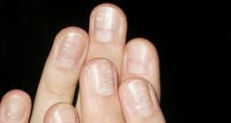

1.3 The learner can explain the nutrient requirements for different groups of people.

The amount of each nutrient we require is dependent on a range of different factors:
- Age
- Growth
- Gender
- Activity level (how active we are)
- Health conditions (e.g. coronary heart disease, diabetes)
- Specific dietary requirements (e.g. nut allergy, lactose intolerance, vegan etc).
Task 1: Explain what the dietary needs of each group below might be and how/why nutrient and energy requirements are different to each other.
Group | Dietary needs | How/why are they different?
Gender:
Male

Female
Activity level:
Very active

Not very active (sedentary)
Health condition:
Obesity

Anorexia
Changes during life:

Pregnancy
Task 2: Use p.112-115 in the textbook to complete the table below to find out about the different dietary requirements and health conditions people may have, which can affect the foods they choose to eat.
Dietary requirements/health conditions | Explain what this type of diet/health condition is | What foods can they not eat? Or what is it they must control? | What foods have been produced for them to eat?
Lactose (milk) intolerance
Nut allergy
Vegetarian
Vegan
Coronary heart disease
Diabetes
Gluten free/ coeliac disease
Task 3: Complete the match up activity to identify the nutrient requirements for different groups of people.
Group |  | Nutrient requirements
Babies and toddlers |  | - Energy requirements decrease as they become less active.  - Protein requirements decrease for men but continue to increase slightly in women.  - The requirements for vitamins and minerals remain the same for both men and women.
Pre-school children  (1-3yrs) |  | - Energy requirements continue to increase and protein requirements increase by approximately 50%.  - Calcium requirement also increases as rapid bone growth occurs.  - Vitamin A, B complex and C increases.  - Girls have a higher requirement than boys for iron (as girls can start to menstruate from 10years old).
Children  (4-10yrs) |  | - During the first 12 weeks of pregnancy woman are advised to take supplements of folic acid to help reduce the risk of their child having a neural tube defect.  - Additional energy from carbohydrates and protein are required only during the last three months of pregnancy.  - Vitamin and mineral requirements should continue to be consumed as normal in order to help the baby grow.
Teenagers |  | - Energy requirements continue to increase and there is a greater need for protein, all the vitamins (except A, C and D) and all the minerals (except iron).  - Avoiding foods high in sugar and fat is important as teenagers often like to snack throughout the day.
Adults |  | - The first 4-6 months of life is a period of rapid growth and development. Breast milk (or infant formula) contains all the nutrients required during this period.  - It is recommended from birth to one year of age babies should be given a daily supplement of vitamin D.  - Requirements for protein, vitamin B complex and iron also increase between 6 and 12 months when weaning (changing from milk to solid food).
Pregnant/lactating mothers |  | - Energy requirements increase because children are active and growing rapidly.  - Protein requirements do not increase much.  - There is an increased need for all the vitamins, except vitamin D  - They should be given whole milk, not skimmed or semi skimmed.  - Care needs to be taken over the amount of dietary fibre eaten. If too many high fibre foods are eaten, there is a danger the child will be unable to eat enough food to satisfy its energy needs.
Elderly |  | - Energy requirements are lower for both men and women  - Muscle tissue decreases and fat tissue increases as a result of being less active (sedentary).  - Requirement for calcium also decreases.  - The requirements for protein and vitamins remain the same.
Task 4: Answer the mock exam style question below. Circle/highlight in the box if you are aiming for a Pass, Merit or Distinction with this answer.
P M D
Alicia is a 14 year old schoolgirl. She often finds she lacks energy and frequently feels tired. She is quite small for her age. She eats very few dairy products and no red meat or fish.

1a. Identify the nutrients that may be missing from Alicia’s diet.
…………………………………………………………………………………………………………………………………………………………………………………………………………………………………………………………………………………………………………………………………………………………………………………………………………………………………………………………………………………………………………………………………………………………………………………………………………………………………………………………………………………………………………………………………………………………………………………………………………………………………………………………………………………………………………………………………………………………………………………………………………………………………………………………………………………………………………………………………………………………………………………………………………………………………………………………………………………………………………………………………………………………………………………………………………………………………………………………………………………………………………………………………………………………………………………………………………………………………………………………………………………………………………………………………………………………………………………………………………………………………………………………………………………………………………………………………………………………………………………………………………………………………………
1b. What impact might a lack of these nutrients have on Alicia’s health and wellbeing?
…………………………………………………………………………………………………………………………………………………………………………………………………………………………………………………………………………………………………………………………………………………………………………………………………………………………………………………………………………………………………………………………………………………………………………………………………………………………………………………………………………………………………………………………………………………………………………………………………………………………………………………………………………………………………………………………………………………………………………………………………………………………………………………………………………………………………………………………………………………………………………………………………………………………………………………………………………………………………………………………………………………………………………………………………………………………………………………………………………………………………………………………………………………………………………………………………………………………………………………………………………………………………………………………………………………………………………………………………………………………………………………………………………………………………………………………………………………………………………………………………………………………………………
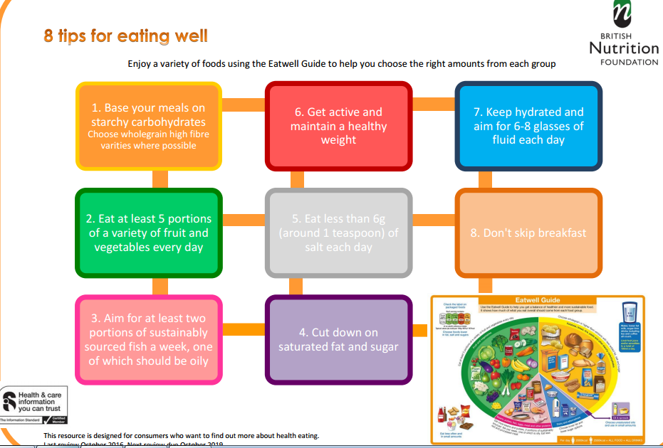
1.4 The learner can explain healthy eating advice.

The UK government have created these 8 tips for eating well. The Eatwell guide has also been created to show us what a balanced diet should look like in terms of portion control of each food group.
You need to be able to explain the healthy eating advice about the following in detail:
- Fat
- Sugar
- Salt
- Fibre (NSP)
- Fruit and vegetables

The question on the exam paper for this A.C is usually analysing a person’s diet. You have to identify how their food choices are affecting their health/wellbeing.
To get a Pass: You need to be able to explain 2 or more of the healthy eating guidelines and how/why these would benefit OR affect the diet you are analysing.
To get a Merit: You need to be able to explain 4 or more of the healthy eating guidelines and how/why these would benefit OR affect the diet you are analysing in detail (linking to foods and nutrients found in them).
To get a Distinction: You need to be able to explain 6 or more of the healthy eating guidelines and how/why these would benefit OR affect the diet you are analysing in thorough detail (linking to a variety of foods and nutrients found in them).
Example answer below for one healthy eating guideline, explaining how someone needs to reduce fat in their diet, as they suffer with coronary heart disease.
Distinction answer:
Reduce the amount of fat you eat, especially saturated fats (mainly animal fats) as having too much could make coronary heart disease worse, by making your cholesterol level rise. It will also make you overweight if you’re taking in excess energy but not using it up doing exercise. Avoiding processed foods and cooking foods yourself will help to reduce your fat intake.
Merit answer:
Reduce the amount of fat you eat, especially saturated fats (mainly animal fats) as having too much could make coronary heart disease worse, by making your cholesterol level rise. It will also make you overweight if you are taking in excess energy but not using it up doing exercise.
Pass answer:
Reduce the amount of fat you eat, especially saturated fats as having too much could make coronary heart disease worse. It will also make you overweight if you are taking in excess energy but not using it up doing exercise.

Task 1: Research the current healthy eating advice in more detail using the following website: https://assets.publishing.service.gov.uk/government/uploads/system/uploads/attachment_data/file/551502/Eatwell_Guide_booklet.pdf
(Try to include the following information: how much we should have each day/portion size examples and any specific examples of foods we should try to eat OR try to avoid/cut down on).
Government guidelines
Fat (saturated fat)
Salt
Sugar
Fibre
Fruit and vegetables
1.5 The learner can explain how nutritional information on food labels can inform healthy eating.

The question on the exam paper for this A.C is usually analysing a food label. You have to explain the nutritional information this label gives to the person buying/eating the food product.
How do we know what’s considered a low, medium or high amount?
TLS (traffic light system)

- The traffic light system is a useful way to compare foods.
- Many food manufacturers and supermarkets are using the traffic light system.
- This scheme has been developed to help consumers associate the colours on the front of pack to the levels of calories, fat, saturated, fat, sugar and salt in a product.
Red = High, eat occasionally, perhaps as a treat or in small quantities
Amber = Medium, eat in moderation, okay most of the time
Green = Low - the healthiest option (the more green, the healthier the option!)

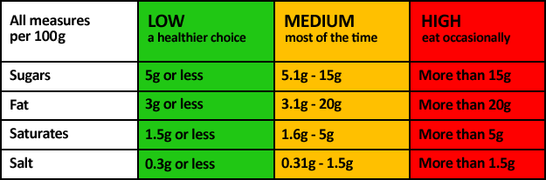

Food labels can be presented in a number of ways. Here are 3 examples:

To get a Pass: You can explain how the nutritional information on the food label informs the consumer about healthy eating. (Identify/explain at least 3 different pieces of information and explain what it gives the consumer in relation to their reference intake allowance for the day). Also identify if the food is high/medium or low in fat, saturated fat, salt or sugar. Explain what some of the nutritional advantages/disadvantages are with what nutrients the food provides.
To get a Merit: You can explain how the nutritional information on the food label informs the consumer about healthy eating and analyse it by explaining how this may affect the consumer’s choices for the rest of the day/impact their lifestyle. (Identify/explain at least 4 different pieces of information and explain what it gives the consumer in relation to their reference intake allowance for the day). Also identify if the food is high/medium or low in fat, saturated fat, salt or sugar. Explain what most of the nutritional advantages/disadvantages are with what nutrients the food provides and what impact this may have on the body.
To get a Distinction: You can explain how the nutritional information on the food label informs the consumer about healthy eating and analyse it by explaining how this may affect the consumer’s choices for the rest of the day/impact their lifestyle. (Identify/explain at least 5 different pieces of information and explain what it gives the consumer in relation to their reference intake allowance for the day). Also identify if the food is high/medium or low in fat, saturated fat, salt or sugar. Explain what all of the nutritional advantages/disadvantages are with what nutrients the food provides and what impact this may have on the body.
Task: Answer the mock exam questions below. Circle/highlight in the box if you are aiming for a Pass, Merit or Distinction with this answer.
1a. Read this food label for a ready-made grilled burger for one person
Explain what the colour coded information shown on the label tells us about
the nutritional content of the product.

……………………………………………………………………………………………………………………………………………………………………………………………………………………………………………………………………………………………………………………………………………………………………………………………………………………………………………………………………………………………………………………………………………………………………………………………………………………………………………………………………………………………………………………………………………………………………………………………………………………………………………………………………………………………………………………………………………………………………………………………………………………………………………………………………………………………………………………………………………………………………………………………………………………………………………………………………………………………………………………………………………………………………………………………………………………………………………………………………………………………………………………………………………………………………………………………………………………………………………………………………………………………………………………………………………………………………………………………………………………………………………………………………………………………………………………………………………………………………………………………………………………………………………………………………………………………………………………………………………………………………………………………………………………………………………………………………………………………………………………………………………………………………………………………………………………………………………………………………………………………………………………………………………………………………………………………………………………………………………………………………………………………………………………………………………………………………………………………………………………………………………………………………
CONTINUE ON THE NEXT PAGE IF NECESSARY

P M D
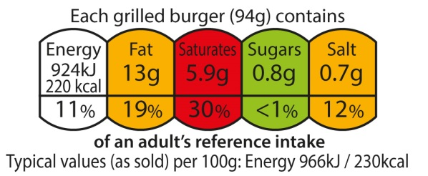

……………………………………………………………………………………………………………………………………………………………………………………………………………………………………………………………………………………………………………………………………………………………………………………………………………………………………………………………………………………………………………………………………………………………………………………………………………………………………………………………………………………………………………………………………………………………………………………………………………………………………………………………………………………………………………………………………………………………………………………………………………………………………………………………………………………………………………………………………………………………………………………………………………………………………………………………………………………………………………………………………………………………………………………………………………………………………………………………………………………………………………………………………………………………………………………………………………………………………………………………………………………………………………………………………………………………………………………………………………………………………………………………………………………………………………………………………………………………………………………………………………………………………………………………………………………

1b. Explain how the nutritional information given in red, amber (orange) and green on this label will help someone who is trying to eat healthily.
………………………………………………………………………………………………………………………………………………………………………………………………………………………………………………………………………………………………………………………………………………………………………………………………………………………………………………………………………………………………………………………………………………………………………………………………………………………………………………………………………………………………………………………………………………………………………………………………………………………………………………………………………………………………………………………………………………………………………………………………………………………………………………………………………………………………………………………………………………………………………………………………………………………………………………………………………………………………………………………………………………………………………………………………………………………………………………………………………………………………………………………………………………………………………………………………………………………………………………………………………………………………………………………………………………………………………………………………………………………………………………………………………………………………………………………………………………………………………………………………………………………………………………………………………………………………………………………………………………………………………………………………………………………………………………………………………………………………………………………………………………………………………………………………………………………………………………………………………………………………………………………………………………………………………………………………………………………………………………………………………………………………………………………………………………………………………………………………………………………………………………………………………………………………………………………………………………………………………………………………………………………………………………………………………………………………………………………………

1.6 Assess a food diary and make recommendations.

The question on the exam paper for this A.C is usually analysing a person’s diet. You have to identify how their food choices are affecting their health/wellbeing. AC 1.4 and 1.6 are usually marked on the same questions.
To get a Pass: You need to be able to identify 2 or more aspects of the diet and explain how they are healthy/unhealthy (identify which foods in particular are healthy/unhealthy) and compare/link this to the healthy eating guidelines or Reference Intakes. Make recommendations of how to improve each unhealthy aspect you identify (e.g. food swaps) and explain how this will benefit the person nutritionally.
To get a Merit: You need to be able to identify 3 or more aspects of the diet and explain how they are healthy/unhealthy (identify which foods in particular are healthy/unhealthy and explain what nutrients they are lacking and the impact this might have on the body) and compare/link this to the healthy eating guidelines or Reference Intakes. Make recommendations of how to improve each unhealthy aspect you identify (e.g. food swaps) and explain how this will benefit the person nutritionally.
To get a Distinction: You need to be able to identify 3 or more aspects of the diet and explain how they are healthy/unhealthy (identify which foods in particular are healthy/unhealthy and explain what nutrients they are lacking and the impact this might have on the body) and compare/link this to the healthy eating guidelines or Reference Intakes. Make detailed recommendations of how to improve each unhealthy aspect you identify (e.g. food swaps) and explain how this will benefit the person nutritionally and what improvements this will make to their body/lifestyle.
YOU CAN ANNOTATE THE DIET TO HELP YOU IDENTIFY THE DIFFERENT ASPECTS.
Task 1: You must ensure your work in Task 1 addresses assessment criteria 1.4 and 1.6. You can refer to the assessment criteria within the grading descriptors at the end of this task.
Adam is a 14 year old boy who has gained some weight in the last year, so he needs you to advise him on how he can improve his diet to become healthier. Adam is a fussy eater and does not like cow’s milk or fish. You ask him to keep a food diary, below is a typical day from his food diary.
Breakfast | Lunch | Dinner | Snacks
2 rounds of toast (white bread) with butter and jam.  Glass of coca cola. | Pizza and chips.  Glass of orange juice. | Baked potato with cheese and baked beans.  Glass of lemonade | A small fruit salad pot.  1 cupcake  A bag of crisps
Physical activity
Walking to school (20 minute walk)
1 hour of P.E (football)
1a. Identify how Adam’s food choices may be affecting his health and well being.
…………………………………………………………………………………………………………………………………………………………………………………………………………………………………………………………………………………………………………………………………………………………………………………………………………………………………………………………………………………………………………………………………………………………………………………………………………………………………………………………………………………………………………………………………………………………………………………………………………………………………………………………………………………………………………………………………………………………………………………………………………………………………………………………………………………………………………………………………………………………………………………………………………………………………………………………………………………………………………………………………………………………………………………………………………………………………………………………………………………………………………………………………………………………………………………………………………………………………………………………………………………………………………………………………………………………………………………………………………………………………………………………………………………………………………………………………………………………………………………………………………………………………………
1b. Using examples from his food diary, describe the changes Adam could make to his food choices in order to make his diet healthier.
…………………………………………………………………………………………………………………………………………………………………………………………………………………………………………………………………………………………………………………………………………………………………………………………………………………………………………………………………………………………………………………………………………………………………………………………………………………………………………………………………………………………………………………………………………………………………………………………………………………………………………………………………………………………………………………………………………………………………………………………………………………………………………………………………………………………………………………………………………………………………………………………………………………………………………………………………………………………………………………………………………………………………………………………………………………………………………………………………………………………………………………………………………………………………………………………………………………………………………………………………………………………………………………………………………………………………………………………………………………………………………………………………………………………………………………………………………………………………………………………………………………………………………
1c. Explain the current healthy eating advice you would give Adam about his diet, to help him eat more healthily.
………………………………………………………………………………………………………………………………………………………………………………………………………………………………………………………………………………………………………………………………………………………………………………………………………………………………………………………………………………………………………………………………………………………………………………………………………………………………………………………………………………………………………………………………………………………………………………………………………………………………………………………………………………………………………………………………………………………………………………………………………………………………………………………………………………………………………………………………………………………………………………………………………………………………………………………………………………………………………………………………………………………………………………………………………………………………………………………………………………………………………………………………
CONTINUE ON THE NEXT PAGE IF NECESSARY
…………………………………………………………………………………………………………………………………………………………………………………………………………………………………………………………………………………………………………………………………………………………………………………………………………………………………………………………………………………………………………………………………………………………………………………………………………………………………………………………………………………………………………………………………………………………………………………………………………………………………………………………………………………………………………………………………………………………………………………………………………………………………………………………………………………………………………………………………………………………………………………………………………………………………………………………………………………………………………………………………………………………………………………………………………………………………………………………………………………………………………………………………………………………………………………………………………………………………………………………………………………………………………………………………………………………………………………………………………………………………………………………………………………………………………………………………………………………………………………………………………………………………………

