Lord of the Flies
By William Golding
1954
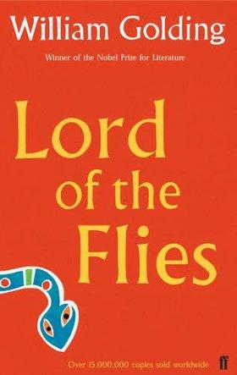

Name:.......................................
Form:...............
English Literature Unit 2
L Banks 2011
Teacher: ………………………………….

Pre-reading
This is what William Golding said about his book, Lord of the Flies:
“That is really what the book is about: if you don’t have rules, that is to say, if you don’t have laws, then you’re lost, you’re finished, you’re gone.”

Think of three rules/laws that affect you:
1……………………………………………….……………………………………………………………...
2……………………………………………………………………………………………………………....
3……………………………………………………………………………………………………………....
Would you be lost without these rules?
………………………………………………………………………………………………………………..
Why?
……………………………………………………………………………………………………………………………………………………………………………………………………………………………………………………………………………………………………………………………………………………....
Think about a time when you and your friends were without adults to enforce any rules. Fill in the table:
How did the atmosphere change?
How did your peers act differently?
Were the rules still obeyed?
Were new rules developed?
Did certain people take charge?
Did some people still follow the rules?
What happened to people who wanted to follow the rules?
What happened to the people that broke the rules?
Think about someone who you consider to be a good leader: ………………………………………………………………………
Quality/skill that makes a good leader: | Why this is necessary:

Imagine you are the leader of the group. What would you do in the following situations?
Someone questions your authority.
Someone tries to compete against you as a leader.
People are picking on one of the members of your group.
Everyone in your group has been threatened and is scared (including you) and they are looking to you for guidance.
Context
Read the information about the book and its author and answer the comprehension questions.

William golding was born on September 19, 1911, in Cornwall. He went to Oxford University where he studied English literature. After graduating from Oxford, he worked briefly as a theatre actor and director, wrote poetry, and then became a schoolteacher. In 1940, a year after England entered World War II, Golding joined the Royal Navy, where he participated in the invasion of Normandy.
Golding’s experience in World War II made him realise how evil humans could be to one another. After the war, Golding returned to teaching and started to write novels. His first and greatest success came with Lord of the Flies (1954), which ultimately became a bestseller in both Britain and the United States after more than twenty publishers rejected it. The novel’s sales enabled Golding to retire from teaching and devote himself fully to writing. Golding died in 1993, one of the most acclaimed writers of the second half of the twentieth century.
Lord of the Flies tells the story of a group of English schoolboys marooned on a tropical island after their plane is shot down during a war. Though the novel is fictional, its exploration of the idea of human evil is at least partly based on Golding’s experience with the real-life violence and brutality of World War II.
Although Golding’s story is confined to the island and a small group of boys, it explores problems and questions universal to the human experience.

In which English county was Golding born?
…………………………....……………………………………………………………………………………..
What did he study at Oxford University?
…………………………………………………………………………………………………………………..
List three jobs that Golding has done in his life.
…………………………………………………………………………………………………………………..
What did Golding do in 1940?
…………………………………………………………………………………………………………………..
What did Golding realise about humans after he’d been involved in WW2?
…………………………………………………………………………………………………………………..
In which year was Lord of the Flies published?
………………………………………………………………………………………………………………….
How many publishers initially rejected it?
………………………………………………………………………………………………………………….
In which year did Golding die?
………………………………………………………………………………………………………………….
How do the boys end up marooned on the island?
………………………………………………………………………………………………………………….
What idea does the novel explore?
………………………………………………………………………………………………………………….
Word Bank
You should learn the spellings and meanings of these words. Please add any words that you learn throughout this course:
WORD | MEANING
symbolism
metaphor
savage
civilisation
allegory
anarchy

Chapter One: The Sound of the Shell
Number the events so that they are in the correct order:
Ralph, Jack and Simon decide to explore the island.

The most impressive entrance is made by a group of choirboys led by the red-haired Jack Merridew, head boy and leader of the choir.
Piggy’s name is revealed to the boys’ general amusement.

A group of boys is marooned on an island after evacuation from a war zone.

The three boys come across a piglet, which Jack almost kills before hesitating. He declares he will spill blood “Next time-!”
Ralph and Piggy are the first on the scene and use a conch to summon other survivors.

One of the choirboys, Simon, faints near the platform where the boys are gathering.

Ralph, Jack and Simon decide to explore the island.

Refer to the opening of the novel. Make a note of the differences between Ralph and Piggy:
Ralph | Piggy

Look at pages 26-28. Fill in the table:
POINT | EVIDENCE | EXPLAIN
The way the choir is introduced makes it seem quite scary.
 | “The creature was a party of boys.”
 | Jack “vaulted on to the platform with his cloak flying.”
 | “Out of this face stared two light blue eyes, frustrated now, and turning, or ready to turn, to anger.”
Jack is insensitive to the choir’s suffering.

Look at pages 37-40. The island setting is described in vivid, physical terms. It is clearly a tropical paradise. Right down words that Golding uses to portray it richness and variety. You may wish to make a note of their meanings too:
Are there any phrases that you have come across that make the island seem a bit threatening? Write them down with the page numbers.
On the following page is the description of the island from the first chapter. Around it are questions for you to consider. Please record your ideas in the spaces provided.
What is the significance of the boat shape?
…………………………………………………………………………………………………………………………………………………………………………………………………………………………………………………………………………
What does this remind you of?
………………………………………………………………………………………………………………………………………………………………
It was roughly boat-shaped: humped near this end with behind them the jumbled descent to the shore. On either side rocks, cliffs, treetops and a steep slope: forward there, the length of the boat, a tamer descent, tree-clad, with hints of pink: and then the jungly flat of the island, dense
green, but drawn at the end to a pink tail. There, where the island petered out in water, was another island; a rock, almost detached, standing like a fort, facing them across the green with one bold, pink bastion.
The boys surveyed all this, then looked out to sea. They were high up and the afternoon had advanced; the view was not robbed of sharpness by mirage.
“That’s a reef. A coral reef. I’ve seen pictures like that.”
The reef enclosed more than one side of the island, lying perhaps a mile out and parallel to what they now thought of as their beach. The coral was scribbled in the sea as though a giant had bent down to reproduce
the shape of the island in a flowing chalk line but tired before he had finished. Inside was peacock water, rocks and weeds showing as in an aquarium; outside was the dark blue of the sea. The tide was running so that long streaks of foam tailed away from the reef and for a moment they felt that the boat was moving steadily astern…
Beyond falls and cliffs there was a gash visible in the trees; there were the splintered trunks and then the drag, leaving only a fringe of palm between the scar and the sea. There, too, jutting into the lagoon was the platform, with insect-like figures moving near it.
To be answered at the end of your reading. What does this become?
…………………………………………………………………………………………………………
‘Astern’ means backwards. Is this important?
……………………………………………………………………………………………………………………………………………………………………………………………………………………
How does this paragraph present the island as isolated?
………………………………………………………………………………………………………………………………………………………………………………………………………………………………………………
How are humans presented as destructive in the final paragraph?
……………………………………………………………………………………………………………..……………………………………………………………………………………………………………………………………………………………………………………………………………………………………………………………………………………………………………………………………………………………………………………………………………………………………………………

The Island
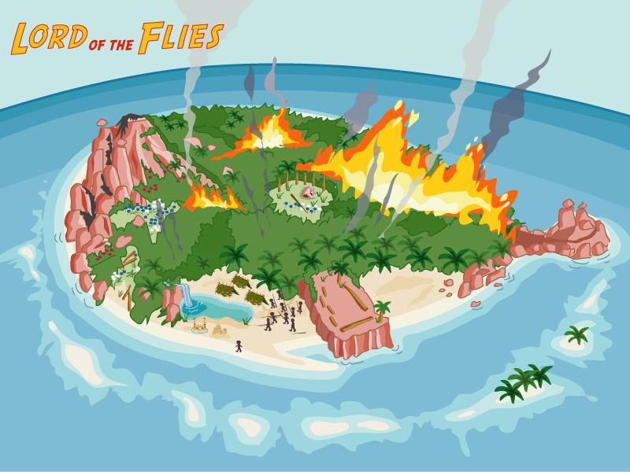

The Conch

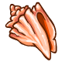
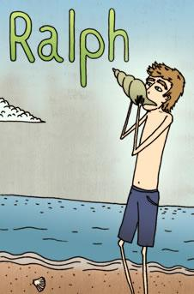
Physical Description
…

What is he like at the beginning of the novel?
….............................................................................................................................................................................................................................................................................................................................................................................................................................……………………………….. …………………………………………………………………………………….............................................................................................................................................................................................................................................................................................................................................................................................................................……………………………….. …....…………………………………………………………………………………….………………………………………………………………………………………………………………………………………………………………………
Any other significant observations
…............................................................................................................................................................................................................................................................................................................................................................................................................................. …………………………. …………………………………………………………………………………….........................................................................................................................................................................................................................................................................................................................................................................................................................................................................................................................................................................................................................................................................................................................................
What he represents
…............................................................................................................................................................................................................................................................................................................................................................................................................................. …………………………. ……………………………………………………………………………………...
How does he change?
…............................................................................................................................................................................................................................................................................................................................................................................................................................. …………………………. ……………………………………………………………………………………....................................................................................................................................................................................
Why does he change?
…............................................................................................................................................................................................................................................................................................................................................................................................................................. …………………………. ……………………………………………………………………………………...............................................................................................................................................................................................................................................................................................................................................................................................................................................................
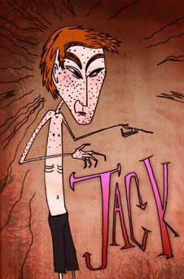
Physical Description
………………………………………………………………………………………………………………………………………………………………………………………………………………………………………………………………………………………………………………………………………………………………………………………………………………………………………………………………………………………………………………………………………………………………………………………………………………………………………………………………………………………………………………………………………………………………………………………………………………

What is he like at the beginning of the novel?
….............................................................................................................................................................................................................................................................................................................................................................................................................................……………………………….. …………………………………………………………………………………….............................................................................................................................................................................................................................................................................................................................................................................................................................……………………………….. …....…………………………………………………………………………………….………………………………………………………………………………………………………………………………………………………………………
What he represents
…............................................................................................................................................................................................................................................................................................................................................................................................................................. …………………………. ……………………………………………………………………………………...
How does he change?
…............................................................................................................................................................................................................................................................................................................................................................................................................................. …………………………. ……………………………………………………………………………………....................................................................................................................................................................................
Why does he change?
…............................................................................................................................................................................................................................................................................................................................................................................................................................. …………………………. ……………………………………………………………………………………...............................................................................................................................................................................................................................................................................................................................................................................................................................................................

Any other significant observations
…............................................................................................................................................................................................................................................................................................................................................................................................................................. …………………………. …………………………………………………………………………………….........................................................................................................................................................................................................................................................................................................................................................................................................................................................................................................................................................................................................................................................................................................................................
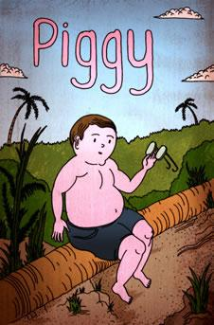
Physical Description
………………………………………………………………………………………………………………………………………………………………………………………………………………………………………………………………………………………………………………………………………………………………………………………………………………………………………………………………………………………………………………………………………………………………………………………………………………………………………………………………………………………………………………………………………………………………………………………………………………
What he represents
…............................................................................................................................................................................................................................................................................................................................................................................................................................. …………………………. ……………………………………………………………………………………...
What is he like at the beginning of the novel?
….............................................................................................................................................................................................................................................................................................................................................................................................................................……………………………….. …………………………………………………………………………………….............................................................................................................................................................................................................................................................................................................................................................................................................................……………………………….. …....…………………………………………………………………………………….………………………………………………………………………………………………………………………………………………………………………

How does he change?
…............................................................................................................................................................................................................................................................................................................................................................................................................................. …………………………. ……………………………………………………………………………………....................................................................................................................................................................................

Any other significant observations
…............................................................................................................................................................................................................................................................................................................................................................................................................................. …………………………. …………………………………………………………………………………….........................................................................................................................................................................................................................................................................................................................................................................................................................................................................................................................................................................................................................................................................................................................................
Why does he change?
…............................................................................................................................................................................................................................................................................................................................................................................................................................. …………………………. ……………………………………………………………………………………...............................................................................................................................................................................................................................................................................................................................................................................................................................................................
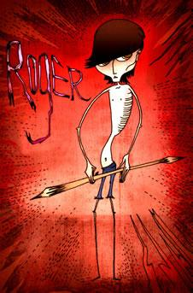
Physical Description
………………………………………………………………………………………………………………………………………………………………………………………………………………………………………………………………………………………………………………………………………………………………………………………………………………………………………………………………………………………………………………………………………………………………………………………………………………………………………………………………………………………………………………………………………………………………………………………………………………
What he represents
…............................................................................................................................................................................................................................................................................................................................................................................................................................. …………………………. ……………………………………………………………………………………...
What is he like at the beginning of the novel?
….............................................................................................................................................................................................................................................................................................................................................................................................................................……………………………….. …………………………………………………………………………………….............................................................................................................................................................................................................................................................................................................................................................................................................................……………………………….. …....…………………………………………………………………………………….………………………………………………………………………………………………………………………………………………………………………

How does he change?
…............................................................................................................................................................................................................................................................................................................................................................................................................................. …………………………. ……………………………………………………………………………………....................................................................................................................................................................................

Any other significant observations
…............................................................................................................................................................................................................................................................................................................................................................................................................................. …………………………. …………………………………………………………………………………….........................................................................................................................................................................................................................................................................................................................................................................................................................................................................................................................................................................................................................................................................................................................................

Why does he change?
…............................................................................................................................................................................................................................................................................................................................................................................................................................. …………………………. ……………………………………………………………………………………...............................................................................................................................................................................................................................................................................................................................................................................................................................................................

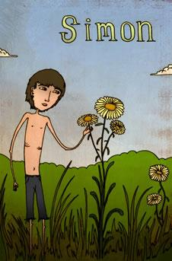
Physical Description
………………………………………………………………………………………………………………………………………………………………………………………………………………………………………………………………………………………………………………………………………………………………………………………………………………………………………………………………………………………………………………………………………………………………………………………………………………………………………………………………………………………………………………………………………………………………………………………………………………

What he represents
…............................................................................................................................................................................................................................................................................................................................................................................................................................. …………………………. ……………………………………………………………………………………...
What is he like at the beginning of the novel?
….............................................................................................................................................................................................................................................................................................................................................................................................................................……………………………….. …………………………………………………………………………………….............................................................................................................................................................................................................................................................................................................................................................................................................................……………………………….. …....…………………………………………………………………………………….………………………………………………………………………………………………………………………………………………………………………

How does he change?
…............................................................................................................................................................................................................................................................................................................................................................................................................................. …………………………. ……………………………………………………………………………………....................................................................................................................................................................................

Any other significant observations
…............................................................................................................................................................................................................................................................................................................................................................................................................................. …………………………. …………………………………………………………………………………….........................................................................................................................................................................................................................................................................................................................................................................................................................................................................................................................................................................................................................................................................................................................................

Why does he change?
…............................................................................................................................................................................................................................................................................................................................................................................................................................. …………………………. ……………………………………………………………………………………...............................................................................................................................................................................................................................................................................................................................................................................................................................................................

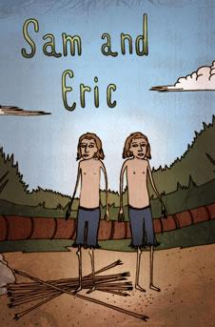
Physical Description
………………………………………………………………………………………………………………………………………………………………………………………………………………………………………………………………………………………………………………………………………………………………………………………………………………………………………………………………………………………………………………………………………………………………………………………………………………………………………………………………………………………………………………………………………………………………………………………………………………

What they represent
…............................................................................................................................................................................................................................................................................................................................................................................................................................. …………………………. ……………………………………………………………………………………...
What are they like at the beginning of the novel?
….............................................................................................................................................................................................................................................................................................................................................................................................................................……………………………….. …………………………………………………………………………………….............................................................................................................................................................................................................................................................................................................................................................................................................................……………………………….. …....…………………………………………………………………………………….………………………………………………………………………………………………………………………………………………………………………

How do they change?
…............................................................................................................................................................................................................................................................................................................................................................................................................................. …………………………. ……………………………………………………………………………………....................................................................................................................................................................................

Any other significant observations
…............................................................................................................................................................................................................................................................................................................................................................................................................................. …………………………. …………………………………………………………………………………….........................................................................................................................................................................................................................................................................................................................................................................................................................................................................................................................................................................................................................................................................................................................................

Why do they change?
…............................................................................................................................................................................................................................................................................................................................................................................................................................. …………………………. ……………………………………………………………………………………...............................................................................................................................................................................................................................................................................................................................................................................................................................................................

Chapter Two: Fire on the Mountain
Number the events so that they are in the correct order:
Jack offers to keep the fire going – ordering his hunters to work in rotation.

The younger boys (the “littluns”) express their concern about a “beastie” on the island.

Jack points out that an army is required for hunting, with Ralph is more concerned with immediate practical issues.
The fire on the mountain top, started using Piggy’s glasses, burns out of control.

Piggy discovers the boy with the birth mark has disappeared.

The three explorers – Ralph, Simon and Jack – return and Ralph blows the conch to call a meeting. He confirms they are on an uninhabited island.
Piggy tells the boys they need to “act proper” if they are to be rescued.

At Ralph’s suggestion, the boys agree to start a fire to attract the attention of passing ships.

Make a note of the differences between Ralph and Jack:
Ralph | Jack

Look again at pages 52-54. Record your ideas about:
a) Jack’s treatment of Piggy (paying particular attention to Golding’s use of language/choice of words).
b) The way in which Golding makes the paragraph beginning “Life became a race…” dynamic and frantic.

a) Jack’s treatment of Piggy (paying particular attention to Golding’s use of language/choice of words).

Words/phrases | Effect

b) the way in which Golding makes the paragraph beginning “Life became a race…” dynamic and frantic.

Words/phrases | Effect
Look again at pages 56-59. Record your ideas about Piggy here:
Point | Evidence | Explain
Piggy seems to have become quite brave. | “Daring, indignant, Piggy took the conch.” | This suggests that he feels upset about being ignored and that he feels quite strongly about what he’s about to say.

The boy with the birthmark is missing. What effect does this have on you, the reader, and what you think about the boys’ time on the island so up until now and in the future?
……………………………………………………………………………………………………………………………………………………………………………………………………………………………………………………………………………………………………………………………………………… ………………………………………………………………………………………………………………………………………………………………………………………………………………………………………………………………………………………………………………………………………………………
Chapter Three: Huts on the Beach
Number the events so that they are in the correct order:
Ralph shows his sense of responsibility by attempting to build shelters, but they are only partially successful due to lack of help from the rest of the boys, apart from Simon.
Ralph view Jack’s hunting as enjoyment.

Ralph and Jack have a difference of opinion; Jack’s obsession with hunting irritates Ralph, who is more concerned with the general well-being of the boys.
Jack goes pig hunting – unsuccessfully.
Simon goes off into the forest on his own.
Jack develops a fascination for hunting pigs.

Look again at pages 61-63. What evidence is there that Jack is fully focused on hunting?
Evidence | Explanation

Technically, Ralph has been elected the leader. However, who do the hunters consider their leader? ……....................................................................................................................................................................

Add notes to Simon’s character file.
Is a fire essential to rescue or is Ralph as obsessed with keeping the fire going as Jack is with hunting? Why do you think the boys are becoming so obsessive? Use evidence from the text to support your ideas.
…….......................................................................................................................................................................…….......................................................................................................................................................................…….......................................................................................................................................................................…….......................................................................................................................................................................…….......................................................................................................................................................................…….......................................................................................................................................................................…….......................................................................................................................................................................…….......................................................................................................................................................................…….......................................................................................................................................................................…….......................................................................................................................................................................…….......................................................................................................................................................................…….......................................................................................................................................................................…….......................................................................................................................................................................…….......................................................................................................................................................................…….......................................................................................................................................................................…….......................................................................................................................................................................…….......................................................................................................................................................................…….......................................................................................................................................................................…….......................................................................................................................................................................…….......................................................................................................................................................................…….......................................................................................................................................................................…….......................................................................................................................................................................……............................................................................................................................................................................................................................................................................

Chapter Four: Painted Faces and Long Hair
Number the events so that they are in the correct order:
The hunters return with a dead pig.
Jack paints his face with clay and charcoal and goes hunting.
Ralph is angry and Piggy backs him up. Jack smashes a lens in Piggy’s glasses.
Ralph spies the smoke of a ship on the horizon.
The littluns play on the beach but their play is disturbed by Roger and Maurice, who destroy their sandcastles. Roger throws stones close to Henry.
Ralph, upset about the fire going out, calls a meeting.
Ralph discovers the fire has gone out.

Look again at pages 86-94. What evidence is there to suggest that Jack enjoys killing the pig AND feels slightly uncomfortable about it?
ENJOYS KILLING: |  | FEELS UNCOMFORTABLE:
Evidence | Explanation | Evidence | Explanation

Do you think the choice of Piggy’s name is significant? Explain your ideas.
…….......................................................................................................................................................................…….......................................................................................................................................................................…….......................................................................................................................................................................……......................................................................................................................................................................................................................................................................................................................................
What do you think is the significance of the “painted faces”?
……................................................................................................................................................................................................................................................................................................................................................…….......................................................................................................................................................................…….......................................................................................................................................................................……..............................................................................................................................................................
Record your thoughts about the treatment of Piggy.
…….......................................................................................................................................................................…….......................................................................................................................................................................…….......................................................................................................................................................................…….......................................................................................................................................................................…….......................................................................................................................................................................

Roger’s cruelty is evident. Why do you think he destroys the littluns’ sandcastles? What motive does he have, if any?
…….......................................................................................................................................................................…….......................................................................................................................................................................…….......................................................................................................................................................................…….......................................................................................................................................................................…….......................................................................................................................................................................…….......................................................................................................................................................................Add notes to Roger’s character file.
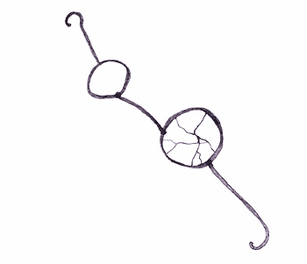
Piggy’s glasses
Chapter Five: Beast from Water
Number the events so that they are in the correct order:
The opinions of Simon and Piggy are ignored.
At the meeting, Ralph lays down the ground rules for behaviour on the island.
Ralph thinks about the seriousness of the forthcoming meeting and of his role as chief.
Simon, Piggy and Ralph discuss what grownups would do, and wish for a signal from them.
Simon and Piggy, fearing what Jack is capable of, urges Ralph to remain as chief.
Discussion turns to the beast, and some of the boys wonder if they are not alone on the island. Jack and Piggy dismiss the idea.
Jack and Ralph have a further disagreement and the meeting ends.

Look again at the description on the first page of the chapter. How does the description mirror Ralph’s feelings?
Description: | What it mirrors:

Ralph points out that “the rules are the only things we’ve got!” How far have the rules of civilised society broken down so far?
……………………………………………………………………………………………………………………………………………………………………………………………………………………………………………………………………………………………………………………………………………………………………………………………………………………………………………………………………………………………………………………………………………………………………………………………………………………………………………………………………………………………………………………………………………………………………………………………………………………………………………………………………………………………………………………………………………………………………………………………………………………………………………………………………………………………………………………………………………………………………………………………………………………………………………………………………………………………………………………………………………………………………………………………………………………………………………………………………………………………………………………………………………………………………………………………………………………………………………………………………………………………………………………………………………………………………………………………………………………………………………………………………………………………………………………………………………………………………………………………………………………………………………………………………………………………………………………………………………...
Think about Percival Wemys Madison. Why do you think Golding has included this character?
………………………………………………………………………………………………………………………………………………………………………………………………………………………………………………………………………………………………………………………………………………………………………………………………………………………………………………………………………………………………………………………………………………………………………………………………………………………………………………………………………………………………………………………………………………………………………………………………………………………………………………………………………………………………………………………………………………………………………………………………………………………………………………………………………………………………………………………………………………………………………………………………………………………………………………………………………………………………………………………………………………………………………………………………Add to your beast mind map.
Chapter Six: Beast from Air
Number the events so that they are in the correct order:
At a meeting, Jack announces that the beast should be hunted down and he ridicules the importance of the conch.
The boys discover that the end of the island would be a good place for a fort.
As Sam and Eric tend the fire, they mistake the parachutist for the beast.
Ralph stresses the boys’ practical needs and the others reluctantly go on with the journey.
The bigger boys, without Piggy, set off to find the beast.
A dead parachutist lands on the island.
Ralph bravely goes first to the unexplored part of a rocky outcrop. He is soon joined by Jack.
**Due to the newest sighting of the beast, Jack now has more power as his hunting skills are needed**
Think about the presentation of Jack and Piggy in this chapter. Record the differences in their characters:
Jack | Piggy
What is the significance of the dead parachutist?

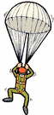

Simon emerges as a complex and important character. Despite the fact that he says and does comparatively little, his speech and actions are highly significant. Take careful notes of what happens whenever his name is mentioned. Include any other observations too.
Chapter Seven: Shadows and Tall Trees
Number the events so that they are in the correct order:
Ralph, Jack and Roger hunt for the beast on the mountain top. They discover the dead parachutist whim they assume is the beast.
Simon tries to reassure Ralph that he’ll get home safely.
Terrified by their discovery, they flee down the mountain.
Ralph is dismayed by the dirty state of the boys and considers the harsher terrain on the other side of the island.
The boys make up a ritual dance to celebrate the hunt. They claim it is just a game, but Robert is hurt.
Jack discovers the tracks of a wild boar.

Golding uses language to imply that the island is a hostile and isolated place. Look carefully at the description of the ocean (p 136-137). Pick out some examples (words and phrases) and explain their effect:
Example | Effect

Look again at Ralph’s flashback to his previous life in Devonport (p138-139). How does it compare to his life on the island? Record your ideas in the following table:
Devonport | Island
He had parents | No adults at all on the island.

Look again at the description of the tribal dance. Using quotations make a list of the way in which the dance develops from fun and controlled to realistic and frightening:
……………………………………………………………………………………………………………………………………………………………………………………………………………………………………
…………………………………………………………………………………………………………………………………………………………………………………………………………………………………....
…………………………………………………………………………………………………………………………………………………………………………………………………………………………………....
…………………………………………………………………………………………………………………………………………………………………………………………………………………………………....
…………………………………………………………………………………………………………………………………………………………………………………………………………………………………....

What does the phrase ‘mob mentality’ mean? Explain how it is a theme in the novel, particularly this chapter.
…………………………………………………………………………………………………………………………………………………………………………………………………………………………………………………………………………………………………………………………………………………………………………………………………………………………………………………………………………………………………………………………………………………………………………………………....

Chapter Eight: Gift for the Darkness
Number the events so that they are in the correct order:
A fire is relit by the platform.
Ralph describes the hunters as “boys armed with sticks”, which hurts Jack.
They sever the sow’s head and put it on a stick.
Ralph, Jack and Roger report what they have seen. Jack argues that the hunters can kill the beast.
Jack goes off with his hunters to kill pigs. They kill a sow that has piglets and decide to invite the others to a feast in order to steal their fire.
Simon, alone in the forest, sees the pig’s head and has a ‘conversation’ with it before losing consciousness.
Jack tries to overthrow Ralph as leader but he is rejected as the new chief and leaves, soon joined by most of the older boys.

Why does Jack think Ralph should step down as leader?
1 …………………………………………………………………………………………………………………………………………………………………………………………………………………………………...
2……………………………………………………………………………………………………………….………………………………………………………………………………………………………………...
3……………………………………………………………………………………………………………….………………………………………………………………………………………………………………....

Think about Jack as a potential leader. What do these following quotations tells us about the style of leader he will be?
He calls a meeting and discusses the beast. When questioned, he shouts, “Quiet!” and “You listen”.
He informs his hunters that he is “going to be chief”.
He talks about the threat of the beast a lot.

Re-read at pages 170-171. Simon communicates with the pig’s head both verbally and with silent understanding. What do the following quotations tell us about him?

Quotation | What it tells us about Simon.
“Simon discovered that he has spoken aloud.”
“Run away, the head said silently, go back to the others.”
“After a while the flies found Simon…”
“…his gaze was held by that ancient, inescapable recognition.”

Look again at page 173. Jack asks “what makes things break up as they do?” What is Piggy’s explanation? Do you agree with him? Give reasons.
……………………………………………………………………………………………………………………………………………………………………………………………………………………………………………………………………………………………………………………………………………………………………………………………………………………………………………………………………………………………………………………………………………………………………………………………………………………………………………………………………………………………………………………………………………………………………………………………………………………………………………………………………………………………………………………………………………………………………………………………………………………………………………………………………………………………………………………………………………………………………………………………………………………………………………………………………………………………………………………………………………………………………………………………………………………………………………………………………………………………………………………………………………………………………………………………………………………………………………………………………………………………………………………………………………………………………………………...
Remind yourself of the final part of the chapter (p177-178). What do you make of Simon’s ‘conversation’ with the Lord of the Flies? Think about:
- What the Lord of the Flies says.
- The voice of the schoolmaster.
- Simon’s reaction to what he ‘hears’.
- The prediction it makes.
……………………………………………………………………………………………………………………………………………………………………………………………………………………………………………………………………………………………………………………………………………………………………………………………………………………………………………………………………………………………………………………………………………………………………………………………………………………………………………………………………………………………………………………………………………………………………………………………………………………………………………………………………………………………………………………………………………………………………………………………………………………………………………………………………………………………………………………………………………………………………………………………………………………………………………………………………………………………………………………………………………………………………………………………………………………………………………………………………………………………………………………………………………………………………………………………………………………………………………………………………………………………………………………………………………………………………………………………………………………………………………………………………………………………………………………………………………………………………………………………………………………………………………………………………………………………………………………………………………………………………………………………………………………………………………………………………………………………………………………………………………………………………………………………………………………………………………………………………………………………………………………………………………………………………………………………………………………………………………………………………………………………………………………………………………………………………………………………………………………………………………………………………………………………………………………………………………………………………………………………………………………………………………………………………………………………………………………………………………………………………………………………………………………………………………………………………………………………………………………………………………………………………………………………………………………………………………………………………………………………………………………………………………………………………………………………………………………………………………………………………………………………………………………………………………………………………………………………………………………………………………………………………………………………………………………………………………………………………………………………………………………………………………………………………………………………………………………………………………………………………………………………………………………………………………………………………………………………………………………………………………………………………………………………………………………………………………………………………………………………………………………………………………………………………………………………………………………………………………………………………………………………………………………………………………………………………………………………………………………………………………………………………………………………………………………………………………………………………………………………………………………………………………………………………………………………………………………………………………………………………………………………………………………………………………………..
Please read and understand the following passage. Then add notes to the Lord of the Flies page (following).
Depending on which religious book you read, Beelzebub is thought of as Satan or at least one of Satan’s collaborators. The meaning of the name Beelzebub is ‘lord/god of the flies’.
Satan, the "the accuser", is the title of various entities, both human and divine, who challenge the faith of humans in the Hebrew Bible. In Christianity and Islam the title became a personal name, and "Satan" changed from an accuser appointed by God to test men's faith to the chief of the rebellious fallen angels. Satan is considered to be the epitome of evil.
Do you think the pig’s head (or Lord of the Flies) is the source of evil on the island? Give alternatives and reasons?
………………………………………………………………………………………………………………………………………………………………………………………………………………………………………………………………………………………………………………………………………………………………………………………………………………………………………………………………………………………………………………………………………………………………………………………………………………………………………………………………………………………………………………………………………………………………………………………………………………………………………………………………………………………………………………………………………………………………………………………………………………………………………………………………………

Lord of the Flies

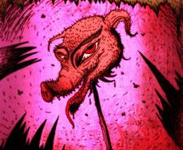

Chapter Nine: A View to a Death
Number the events so that they are in the correct order:
Jack asks who will join his tribe and he and Ralph argue over where the conch can be used.
Simon stumbles into the dancing circle.
The boys see Simon as the beast and kill him in a frenzied attack.
Ralph and Piggy join Jack’s party where they are eating meat and having a feast.
Jack encourages his tribe to perform their dance.
The bodies of Simon and the parachutist were washed out to sea.

Simon sees the dead parachutist and discovers the truth about the beast. He heads off to tell the others.
There is a thunderstorm and Piggy senses trouble.

Remind yourself of the opening of this chapter (p179-180). You know what happens to Simon later in the chapter. Pick out the clues that appear in this opening. Record them in the table with an explanation.
Clue (quotation) | Explanation
**This technique is called foreshadowing**
Reread the dance section (p187-189). How does Golding
- make the boys seem animalistic and extremely violent?
- create tension?
a) How does Golding make the boys seem animalistic and extremely violent?

Words/phrases | Effect

b) How does Golding create tension?

Words/phrases | Effect

Chapter Ten: The Shell and the Glasses
Ralph, Piggy and the twins try, unsuccessfully, to relight the fire. Ralph shows signs of confusion and the give up on the fire for the evening.
Piggy and Ralph talk about the events of the previous night.
Jack and two of his hunters attack and steal Piggy’s glasses.
Jack is delighted with his achievement – “He was a chief now in truth”.
Samneric join Piggy and Ralph. Guilt-ridden, the four boys lie to each other about their involvement.
In their shelters that night, Ralph and the others hear noises outside.
Jack and his hunters set up camp at the far end of the island.

Thinking about the title and events of the chapter, add to your notes on the conch and Piggy’s glasses.
Thinking about what was happening in the world leading up to the publication of the book, what does Jack’s style of leadership represent?
……………………………………………………………………………………………………………………………………………………………………………………………………………………………………………………………………………………………………………………………………………………………………………………………………………………………………………………………………………………………………………………………………………………………………………………………………………………………………………………………………………………………………………………………………………………………………………………………………………………………………………………………………………………………………………………………………………………………………………………………………………………………………………………………………....

Thinking originally, does Jack believe in the beast or is he using fear as a method of control? You should find evidence that supports both ideas and write your response in the space provided. Remember to use paragraphs. During your response, you must answer the question – what do you think?
…………………………………………………………………………………………………………………………………………………………………………………………………………………………………………………………………………………………………………………………………………………………………………………………………………………………………………………………………………………………………………………………………………………………………………………………………………………………………………………………………………………………………………………………………………………………………………………………………………………………………………………………………………………………………………………………………………………………………………………………………………………………………………………………………………………………………………………………………………………………………………………………………………………………………………………………………………………………………………………………………………………………………………………………………………………………………………………………………………………………………………………………………………………………………………………………………………………………………………………………………………………………………………………………………………………………………………………………………………………………………………………………………………………………………………………………………………………………………………………………………………………………………………………………………………………………………………………………………………………………………………………………………………………………………………………………………………………………………………………………………………………………………………………………………………………………………………………………………………………………………………………………………………………………………………………………………………………………………………………………………………………………………………………………………………………………………………………………………………………………………………………………………………………………………………………………………………………………………………………………………………………………………………………………………………………………………………………………………………………………………………………………………………………………………………………………………………………………………………………………………………………………………………………………………………………………………………………………………………………………………………………………………………………………………………………………………………………………………………………………………………………………………
Chapter Eleven: Castle Rock
Roger leans on the lever with catapults a heavy rock towards Piggy.
The conch group decide to confront Jack and his hunters.
Samneric are captured by the hunters.
Ralph is unable to light the fire without Piggy’s glasses.
Ralph is now alone, forced to escape as the hunters hurl spears in his direction.
Piggy is killed by the falling rock and the conch is destroyed.
A scuffle breaks out between the two groups at Castle Rock.
Add to your conch page.
Piggy asks, “Which is better – to have rules and agree, or to hunt and kill?” What do you think and why?
……………………………………………………………………………………………………………………………………………………………………………………………………………………………………………………………………………………………………………………………………………………………………………………………………………………………………………………………………………………………………………………………………………………………………………………………………………………………………………………………………………………………………………………………………………………………………………………………………………………………………………………………………………………………………………………………………………………………………………………………………………………………………………………………………...
Why do you think Golding chose to have Piggy killed, and in this way?
………………………………………………………………………………………………………………………………………………………………………………………………………………………………………………………………………………………………………………………………………………………………………………………………………………………………………………………………………………………………………………………………………………………………………………………………………………………………………………………………………………………………………………………………………………………………………………………………………………………………………………………………………………………………………………………………………………………………………………………………………………………………………………………………………
Chapter Twelve: Cry of the Hunters
Ralph encounters the pig’s head and experiences fear and anger, lashing out at it and taking away the spear that supported it.
Ralph becomes aware that he is totally alone.
Ralph, exhausted, collapse on the beach. He looks up to see the friendly face of a rescuing naval officer.

Jack sets most of the island on fire to smoke Ralph out.
Ralph considers his options as he tries to hide and avoid danger.
The smoke from the fire is seen by a passing ship.
Ralph goes to speak to Samneric and Castle Rock, but their manner is discouraging, telling Ralph that Roger has “sharpened a stick at both ends”.
Jack and the hunters track Ralph as if he were and animal.

Answer the following questions:
What do you think the pig’s head represents for Ralph?
……………………………………………………………………………………………………………………………………………………………………………………………………………………………………………………………………………………………………………………………………………………...
How are the hunters shown to be more like animals than boys?
……………………………………………………………………………………………………………………………………………………………………………………………………………………………………………………………………………………………………………………………………………………………………………………………………………………………………………………………………………………………………………………………………………………………………………………………………………………………………………………………………………………………………………...
How is the fact that Jack sets the island on fire ironic?
………………………………………………………………………………………………………………………………………………………………………………………………………………………………………………………………………………………………………………………………………………………
As readers we are given insight to events that the characters do not always have. This is called dramatic irony. How can you tell that Ralph does not appreciate the danger he is in? Record your ideas, using evidence from the text to support your point.
…………………………………………………………………………………………………………………………………………………………………………………………………………………………………………………………………………………………………………………………………………………………………………………………………………………………………………………………………………………………………………………………………………………………………………………………………………………………………………………………………………………………………………………………………………………………………………………………………………………………………………………………………………………………………………………………………………………………………………………………………………………………………………………………………………………………………………………………………………………………………………………………………………………………………………………………………………………………………………………………………………………………………………………………………………………………………………………………………………………………………………………………………………………………………………………………………………………………………………………………………………………………………………………………………………………………………………………………………………………………………………………………………………………………………………………………………………………………………………………………………………………………………………………………………………………………………………………………………………………………………………………………………………………………………………………………………………………………………………………………………………………………………………………………………………………………………………………………………………………………………………………………………………………………………………………………………………………………………………………………………………………………………………………………………………………………………………………………………………………………………………………………………………………………………………………………………………………………………………………………………………………………………………………………………………………………………………………………………………………………………………………………………………………………………………………………………………………………………………………………………………………………………………………………………………………………………………………………………………………………………………………………………………………………………………………………………………………………………………………………………………………………………
The Ending of the Novel
“And in the middle of them, with filthy body, matted hair, and unwiped nose, Ralph wept for the end of innocence, the darkness of man’s heart, and the fall through the air of the true, wise friend called Piggy.”

How does the naval officer view what he sees, that is, the aftermath of the hunt for Ralph?
…………………………………………………………………………………………………………………………………………………………………………………………………………………………………………………………………………………………………………………………………………………………………………………………………………………………………………………………………………………………………………………………………………………………………………………………...
How does the naval officer view Ralph?
……………………………………………………………………………………………………………………………………………………………………………………………………………………………………………………………………………………………………………………………………………………...
How does the naval officer view Jack?
……………………………………………………………………………………………………………………………………………………………………………………………………………………………………………………………………………………………………………………………………………………...
What is the significance of Percival forgetting his name?
…………………………………………………………………………………………………………………………………………………………………………………………………………………………………………………………………………………………………………………………………………………………………………………………………………………………………………………………………………………………………………………………………………………………………………………………...
Why does Ralph weep?
…………………………………………………………………………………………………………………………………………………………………………………………………………………………………………………………………………………………………………………………………………………………………………………………………………………………………………………………………………………………………………………………………………………………………………………………...

Why do the other boys weep?
…………………………………………………………………………………………………………………………………………………………………………………………………………………………………………………………………………………………………………………………………………………………………………………………………………………………………………………………………………………………………………………………………………………………………………………………...
What kind of world do you think the boys are returning to?
……………………………………………………………………………………………………………………………………………………………………………………………………………………………………………………………………………………………………………………………………………………………………………………………………………………………………………………………………………………………………………………………………………………………………………………………
Write about the ending of the novel.
- How does it make you feel?
- The naval officer asks, “What have you been doing? Having a war or something?”
- Do you think the boys are really being ‘rescued’?
- Are you satisfied with the ending?
…………………………………………………………………………………………………………………………………………………………………………………………………………………………………………………………………………………………………………………………………………………………………………………………………………………………………………………………………………………………………………………………………………………………………………………………………………………………………………………………………………………………………………………………………………………………………………………………………………………………………………………………………………………………………………………………………………………………………………………………………………………………………………………………………………………………………………………………………………………………………………………………………………………………………………………………………………………………………………………………………………………………………………………………………………………………………………………………………………………………………………………………………………………………………………………………………………………………………………………………………………………………………………………………………………………………………………………………………………………………………………………………………………………………………………………………………………………………………………………………………………………………………………………………………………………………………………………………………………………………………………………………………………………………………………………………………………………………………………………………………………………………………………………………………………………………………………………………………………………………………………………………………………………………………………………………………………………………………………………………………………………………………………………………………………………………………………………………………………………………………………………………………………………………………………………………………………………………………………………………………………………………………………………………………………………………………………………………………………………………………………………………………………………………………………………………………………………………………………………………………………………………………………………………………………………………………………………………………………………………………………………………………………………………………………………………………………………………………………………………………………………………………………………………………………………………………………………………………………………………………………………………………………………………………………………………………………………………………………………………………………………………………………………………………………………………………………………………………………………………………………………………………………………………………………………………………………………………………………………………………………………………………………………………………………………………………………………………………………………………………………………………………………………………………………………………………………………………………………………………………………………………………………………………………………………………………………………………………………………………………………………………………………………………………………………………………………………………………………………………………………………………………………………………………………………………………………………………………………………………………………………………………………………………………………………………………………………………………………………………………………………………………………………………………………………………………………………………………………………………………………………………………………………………………………………………………………………………………………………………………………………………………………………………………………………………………………………………………………………………………………………

Descent into Savagery
Below is a selection of events from the novel. First, put them in the right order by numbering them. Then, plot them on the graph to show whether you think the boys’ behaviour is civilised or savage.
Jack paints his face and does a war dance.
Ralph, Piggy and the twins go to talk to Jack’s gang. Roger pushes a rock off the cliff, killing Piggy and Breaking the conch.
Jack challenges Ralph’s authority and goes off alone, joined later by the other boys.
Jack has the opportunity to kill a pig but does not “because of the enormity of the knife descending…because of the unbearable blood.”
Jack’s gang steal Piggy’s glasses, leaving Ralph, Piggy and Samneric with no fire.
Samneric are forced to join Jack’s tribe. They tell Ralph that there are plans to hunt him down and that Roger has sharpened a stick at both ends.
Jack and his gang kill a pig and put the head on a “stick sharpened at both ends” as a gift to the beast.
Jack’s gang hunts Ralph down.

The boys decide that whoever wants to talk in a meeting must hold the conch.

As Simon stumbles out of the forest to tell the boys about the parachutist, the other boys attack and kill him.
Civilised

Savage
1 2 3 4 5 6 7 8 9 10
Events from the novel
Choose two events – one civilised and one savage – and explain why you plotted them at that point.

Event #1: ……………………………………………………………………………………………………………………………………………………………………………………………………………………………………………………………………………………………………………………………………………………………………………………………………………………………………………………………………………………………………………………………………………………………………………………………………………………………………………………………………………………………………………………………………………………………………………………………………………………………………………………………………………………………………………………………………………………………………………………………………………………………………………………………………………………………………………………………………………………………………………………………………………………………………………………………………………………………………………………………………………………………………………………………………………………………………………………………………………………………………………………………………………………………………………………………………………………………………………………………………

Event #2: ……………………………………………………………………………………………………………………………………………………………………………………………………………………………………………………………………………………………………………………………………………………………………………………………………………………………………………………………………………………………………………………………………………………………………………………………………………………………………………………………………………………………………………………………………………………………………………………………………………………………………………………………………………………………………………………………………………………………………………………………………………………………………………………………………………………………………………………………………………………………………………………………………………………………………………………………………………………………………………………………………………………………………………………………………………………………………………………………………………………………………………………………………………………………………………………………………………………………………………………………………
Themes

MOB MENTALITY

LOSS OF INNOCENCE

NEED FOR CIVILISATION

GOOD
VS. EVIL

Metaphors in the Novel
Literal | Metaphorical | Key Quotation
Piggy’s glasses

The island

The conch

The Beast

Face paint

Fire/smoke

The parachutist

Leadership
“Because the rules are the only thing we’ve got!”
“Bollocks to the rules!”

Consider the different ways in which Ralph and Jack each become leaders and their ways of leading ‘their people’.
Why does Ralph become leader?

How does Jack become ‘Chief’?

How does Ralph lead?

Do you think he’s a good leader? Why?

How does Jack lead?

Do you think he’s a good leader? Why?

Golding and War

Golding was horrified by what war revealed about people's capacity to harm their fellow humans. He was appalled by what happened in the Nazi concentration camps, and by the way the Japanese mistreated their prisoners. He was appalled too by the consequences of the British and American mass bombing against civilians - and even by what he himself did as a naval officer.
During the war the British justified all the destruction they wrought on the grounds that they had 'right' on their side, but Golding came to question this smug assumption. He gradually learned to see all human nature as savage and unforgiving: he knew that even the 'goodies' can become 'baddies'. In the novel Ralph and Piggy get as involved in the dance that leads to the killing of Simon as Jack and his tribe are.
World War 2 ended in 1945. The United Nations was set up after the war to try to ensure that a global conflict never happened again, but in 1954, when Lord of the Flies was published, the threat of a nuclear war was still very real. It was entirely plausible to the novel's original audience that an atom bomb really could destroy civilisation.
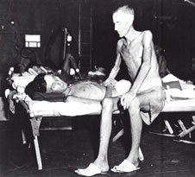
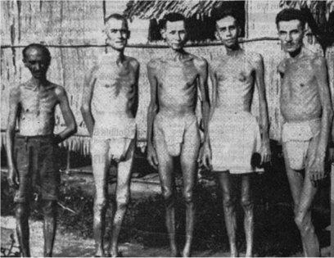
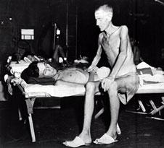

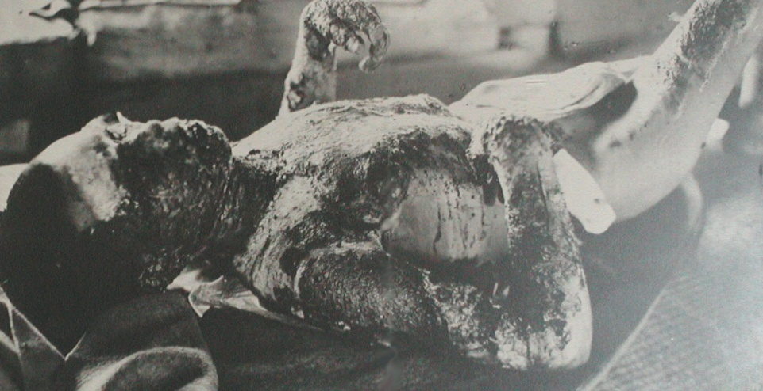
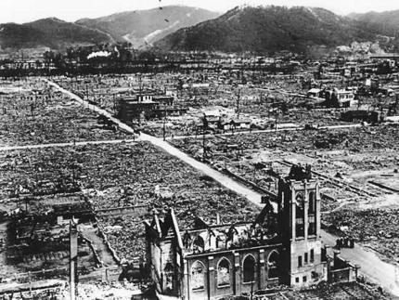

Desert Islands
Most imaginary desert islands are peaceful paradises where the shipwrecked traveller manages to continue living pretty much as before - think of Robinson Crusoe or Desert Island Discs!
In a book called Coral Island by RM Ballantyne, published in 1857, 100 years before Golding's book, three young British boys are shipwrecked on a desert island and have to survive without any adults. Brave and resourceful, they thoroughly enjoy their experience and there is never a hint of trouble. As one of the characters, Peterkin, says, “There was indeed no note of discord whatever in that symphony we played together on that sweet coral island.”
From his experience as a teacher, Golding knew that the idyllic life of Coral Island could never exist in real life. So, he set out to write a novel that showed his ideas about the darker side of human nature starting from the same basis: boys stranded on a desert island, away from all civilising influences. Lord of the Flies was the r
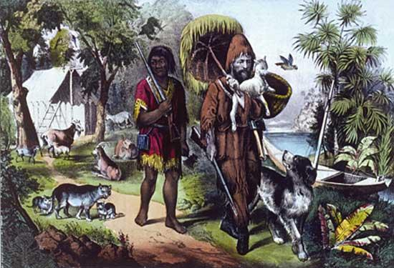
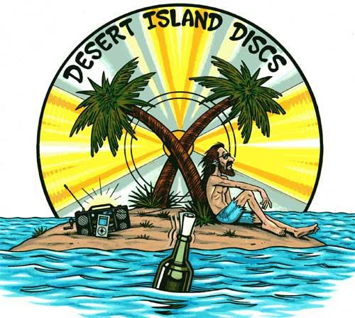

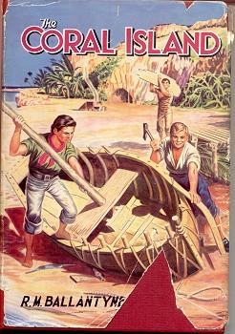
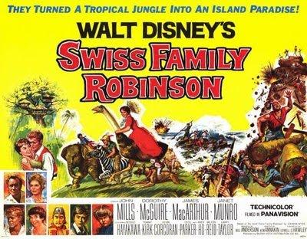

Essay Questions

How much do you think Ralph is to blame for what goes wrong on the island? Write about:
- the ideas Ralph has about life on the island at the start of the novel
- the decisions Ralph makes
- how the writer presents the character of Ralph other reasons for things going wrong

What do you think Golding has to say about evil in the lord of the flies? How does he convey his ideas to the reader?

What is the importance of Simon in Lord of the Flies?
- the importance of the part Simon plays in the plot
- how Simon is different from the other boys
- what Simon might represent
- the ways the writer uses Simon to convey his ideas

Simon says: ‘maybe there isn’t a beast.’
Ralph says: ‘But there isn’t a beast.
Jack says: ‘we’ll make sure when we go hunting.’

How does Golding use the beast in the novel as a whole? You should write about:
- What the beast may symbolise
- The way the boys’ ideas about the boy change
- What effect the beast has on the boys.

