**Computing Dictionary**

**Introduction**

**Information:**

As you go through your computer science lessons you are very likely to come across technology terms that are new to you.

Some terms you will learn about during your lessons. But there are others that may not be explained, or you might forget their meaning.

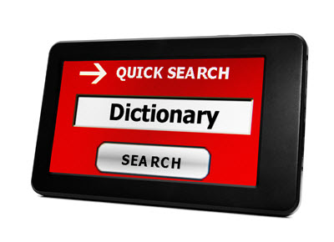

**Task**

**Do this:**

Your task today, is to start a 'Computing Terms' dictionary.

* Open a new document and save it to your area with a sensible name.
* Make a table with three columns, like the one shown below (you can format it with your own style):

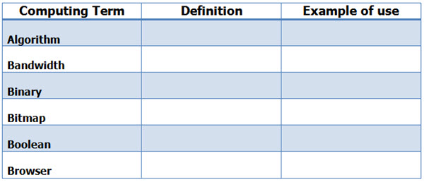

We have added a few words to help you get started

* Write a definition for each of these words and give an example for each of them
* Use the Teach-ICT glossary [**CLICK HERE**](http://www.teach-ict.com/glossary/A.htm)
* Add them to your dictionary, along with a definition and example

# House of the future

## Introduction

#### Information:

Our homes are filled with a vast amount of technology. Most people have televisions, smart phones, tablets, computers, central heating systems, washing machines etc

New advances are being made all the time. Things that, until recently, would only have been seen in a sci-fi movie are now starting to appear in the marketplace.

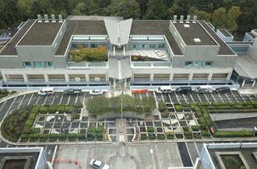

## Task 1

#### Read this:

Your task today, is to undertake your own research to find examples of technology that we might find in our homes within the next decade.

* Look a bit further into the future, what might we see in the next 20 or even 30 years?



Here are some links to get you started:

* [Rightmove - homes of the future](http://www.rightmove.co.uk/viz/home-of-the-future/)
* [The Guardian future homes](https://www.theguardian.com/technology/2015/dec/04/tech-home-future-robots-living-smart)
* [Future technology - future homes](http://www.futuretechnology500.com/index.php/future-homes/)
* [Future for all - smart homes](http://www.futureforall.org/home/homeofthefuture.htm)
* [Popular mechanics - house of the future](http://www.popularmechanics.com/home/how-to/g1009/the-house-of-the-future/)

## Task 2

#### Write this:

* When you have completed your research, write a short report about your findings
* Write about some of the technology that we are very likely to see in the near future
* Describe some of the technology that you would really like to see in your home
* Discuss how you think our lives will change if some of this technology becomes a reality

**Emails**

**Introduction**

**Information:**

We take emails for granted, they are just another way to communicate with someone. But how did you first find out what an email was? How did you learn to send one?



**Task 1**

**Do this:**

Undertake your own research to find out the answers to the following questions:

* + What does the 'E' in E-mail stand for?
  + What is an email?
  + What software and/or services are needed to send an email?
  + Why might someone send an email rather than an IM?
  + What is the inbox?
  + What does 'cc' mean?
  + What does 'bcc' mean?
  + What is the average file size limit for attachments?
  + What is a contacts or address book?



**Create this:**

* Create a poster, a leaflet or a presentation containing the answers to these questions
* Think about who your work is aimed at. Choose:
  + appropriate fonts
  + suitable images
  + the correct amount of text for your chosen output

# Shop til you drop: a family budget

## Introduction

### What do I have to do?

You are going to be given a 'budget'.

You will work in pairs to allocate a budget, ensuring that you get all of the items needed by this family for a week:



## Task

#### Information:

* The family consists of:
  + Mum, aged 32
  + Dad, aged 35
  + Daughter aged 8
  + Son aged 6

* Your budget, for everything, for the week is £175. You must 'purchase' (don't actually do this in real life):

* A new outfit for each family member (You do NOT have to include shoes, coats, bags etc)

* You must also plan all meals for 5 days, including:
  + Breakfast
  + Lunch
  + Evening meal
* All meals must be healthy and nutritious
* The family are happy to eat the same breakfast each day but they would like different lunches/evening meals

* When you have found the items that you wish to "purchase", create a presentation showing:
  + Each of the outfits
  + Each of the meals you have planned
  + What you have spent
  + How much, if any, money you have left at the end of the week.

# Icon Scrabble and Codes

## Introduction

### 

Many companies use icons so that you instantly recognise their brand.

Look at the image below. How many companies/ brands do you recognise?

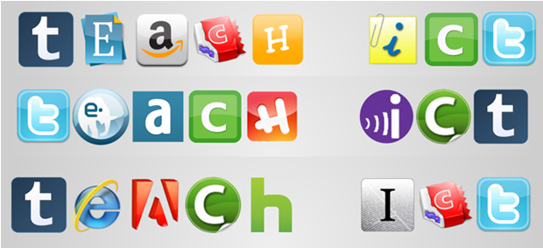

## Task 1

#### Do this:

* Think of a computer/ technology word that is at least 7 letters long
* Go to the website: www.iconscrabble.com
* Type your word into the white box
* Click the 'scrabble' button

## Task 2

#### Do this:

* Download or screen print your 'scrabbled' word
* Paste the image into a document
* Crop around any unwanted areas so that it looks like our version (in the image above)

## Task 3

#### Do this:

* Underneath your image, create a table in your document like this one:

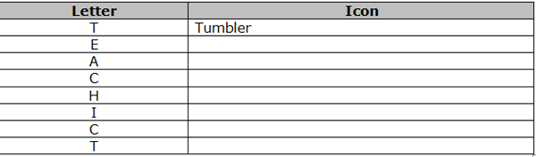

* In the first column, write the letters of your word, one letter per line
* In the second column, identify the organisation that the icon represents

## Task 4

#### Do this:

* Use the icon scrabble website to try out another word.
* Did you come across any different icons?

## Task 5

#### Do this:

* Get yourself a piece of blank A4 paper
* Write out the letters of the alphabet - leave plenty of space next to each one
* Create a new version called 'technology scrabble code'
  + For example, you could draw a computer to represent 'c' and a 'save' image to represent 's'
  + Or a 'save' image to represent 's'
  + Or a 'DVD' image to represent 'd'
* If you get stuck for ideas, use the teach-ict.com glossary section
* If you have time, try out your version of technology scrabble code on your friends.