Cornflake Goujons
Group:….. Making on:………………………….
Don’t forget to weigh out ingredients at home (if possible) and bring a tub AND food bag.
Ingredients:
- 2-3 skinless/boneless chicken breasts (raw) or 4 quorn chicken fillets.
- 140g cornflakes
- 3 tbsp plain flour
- 2 medium eggs
- Salt and pepper (1 tspn of each)
- A large food/freezer bag (this will be used to crush the cornflakes)

Method
- Preheat the oven to 200°C/gas 6. Collect a baking tray lined with foil.
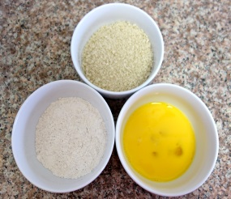
- Put the cornflakes in a food bag and seal. Wrap the bag in a tea towel and use a rolling pin to roll on top of the bag to crush the cornflakes into smaller pieces.
- Collect 3 bowls, put the cornflakes in the first, then flour in the second and then crack open the eggs into the third. Beat the eggs with a fork.
- Stir the salt and pepper into the flour.
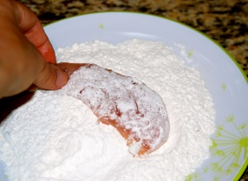
- Use a red chopping board and knife to chop up the chicken into smaller chunks. If using Quorn use a white chopping board.
- Pick up your first piece of chicken and place it into the seasoned flour and coat it. Shake off the excess.
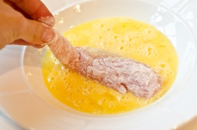
- Then dip it into the beaten egg, turning to coat it.
- Last, dip the chicken into the crushed cornflakes, making sure each piece is completely covered.
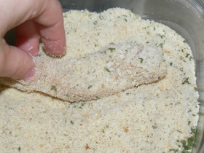
- Space the coated pieces out on the baking tray and repeat until all the chicken is done.
- Cook for 15-20 minutes until golden, crisp and cooked through.
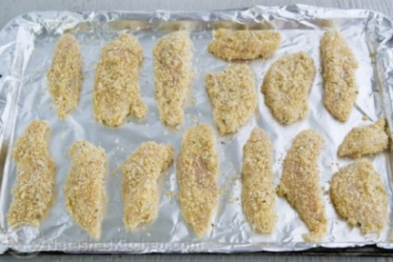
- Take out of the oven and leave to cool on a wire rack.
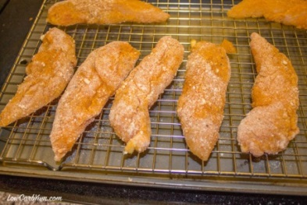
- Fold up the foil and carefully dispose of in the bin. Wash the tray/wire rack and other equipment and place the goujons in your tub.

