COMPUTING AND ICT
DEPARTMENT

Department Vision:
Automatic computing radically changes how humans solve problems, and even the kinds of problems we can only imagine solving. Computing has changed the world more than any other invention over the past hundred years and across the full range of industry sectors. This has come to pervade nearly all human endeavours and we are just at the beginning of the revolution. It will have extraordinary implications on the range of skills that today’s young people will require. It is our responsibility therefore, to enable our future peers with computing knowledge that will keep up with the pace of technological change, so they remain effective and well-informed moral citizens.
Aims
- Ensure that all pupils have a broad and balanced Computing/ICT curriculum
- Encourage pupils to gather, store, process, and present information through activities in a range of contexts
- To support and advance students in becoming computer engineers and program developers
- Provide pupils with opportunities to analyse, design, implement and document Computing/ICT systems for use by others
- Encourage pupils to develop an understanding of the wider applications and effects of Computing/ ICT especially on their future choices
- Encourage pupils to solve problems using Computing/ICT and associated principles and techniques
- Provide pupils with a broad and balanced view of the range of applications and information systems and an understanding of their capabilities and limitations
- To enhance learning and confidence in Computing/ICT through incorporating their own experiences
- Committed to raising high expectations of student attainment
- We also aim to provide opportunities to engage with the Computing/ICT curriculum outside of lessons: KS4 intervention, enrichment days and STEM days,
Key Stage 3 Curriculum Plan (This will be your long-term plan / SOL overview)
 | Autumn Term 1 | Autumn Term 2 | Spring Term 3 | Spring Term 4 | Summer Term 5 | Summer Term 6
YEAR 7 | Baseline Test & Intro to computing resources  Computer Ethics: UCSR & Cyber Security | Spreadsheet Modelling | Games Prog in Scratch: sequence, selection and repetition | Algorithms (Flowol): Pseudocode, Flow chart design | AI and Machine Learning: Origins and uses of AI (Robotics) | Revision & End of Year Exam:  Unit overspill from previous terms, KO’s & Revision Booklets
YEAR 8 | Benchmark Test  Understanding Computers 1: Input, Output, Storage, Memory, CPU | Understanding Computers 2: Systems Software (OS, Embedded & Apps) | Understanding Computers 3: Number Bases (Binary – Terms, Conversion and Arithmetic) Hex (Conversions) | Representing Data: ASCII, Extended ASCII, Unicode, Images, Sound, Compression | Python Programming: Introduction | Revision & End of Year Exam:  Unit overspill from previous terms, KO’s & Revision Booklets
YEAR 9 | Benchmark test  Networks 1: Network Hardware, Types (server, peer to peer), Topologies, Protocols, Packet Tracer (Network Building) | Networks 2: Network Security, Threats, Encryption | IDLE Languages and VB Programming: Study into different languages and prog skills | Computational Thinking: Algorithms, Pseudo Code, Searching and Sorting  Benchmark T | Year 9 Uplift to GCSE  Python Programming: Fundamentals | Year 9 Uplift to GCSE  Python Programming: Next steps (procedures, functions)

Key Stage 4 Curriculum Plan: Computing Specification code J277 (This will be your long-term plan / SOL overview)
Students will experience the OCR Computing GCSE from an engineering and theory-based standpoint in today’s modern technology. The course has been designed to transition students into Computer Science A-level or the modern workplace. It does this by developing valuable computational thinking and how to apply it through a programming language. A specification of the course can be found here: https://www.ocr.org.uk/Images/558027-specification-gcse-computer-science-j277.pdf
As well as covering the below content, students must undertake a programming task to either a specification or as small problem-solving tasks during the course.
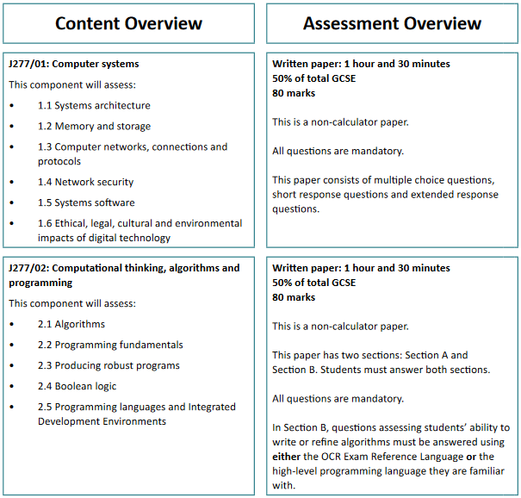

 | Autumn Term 1 | Autumn Term 2 | Spring Term 3 | Spring Term 4 | Summer Term 5 | Summer Term 6
YR 10 | 1.1.1 Systems Architecture  1.1.2 CPU Performance  2.1.1 Computational Thinking  2.1.2 Designing, creating Algorithms | 1.1.3 Embedded Systems​  2.4.1 Boolean Logic​  1.2.1 Primary Storage  1.1.2 Secondary Storge​  Programming Skills - Python Workbook | 1.2.3 Units​  1.2.4 Data storage – Numbers​  1.2.5 Data storage – Characters, images, Sound, Compression​ | 2.2.1 Programming fundamentals – Variables, Operators, Sequencing​  2.2.2 Data Types​  2.2.3 Additional programming Techniques​ | 2.2.3 Additional programming techniques and Practical Programming Skills​  Python Programming: Concepts and Project start | 1.3.1 Networks and topologies​  1.3.2 Wired and wireless networks, protocols and layers​  1.4.1 Threats to Computers​  1.4.2 Vulnerability prevent
YR 11 | 1.4.1 Threats to computer systems and network​ cont  2.3.1 Defensive design​  2.3.2 Testing​ | 1.5.1 Operating Systems  1.5.2 Utility software​  1.6.1 Digital Impacts: Ethical, legal, cultural and environmental  2.5.1 Languages and 2.5.2 The Integrated Development Environment (IDE)​ | Programming Revision​  2.1.3 Searching and sorting algorithms.​  Searching and Sorting Practical Programming skills​ | A further look at Algorithms: Designing, refining  Additional programming technique: Arrays, SQL search read, write and store  Full Course Revision | Revision and final exam

Please double click these icons for the GCSE course information and knowledge organiser:

Revision Booklets:

They contain all relevant information the students will need to complete the course. Past exam papers will be made available but are also downloadable from the OCR website.

Key Stage 4 Curriculum Plan: CISCO Extended IT Essentials (EITE)
The high demand for entry level professionals who possess excellent information and communication technology (ICT) skills is a driving force behind the certification that is offered by CISCO and Pensby High School. Students who are exposed to the Cisco Networking Academy, Extended IT Essentials course, will obtain a certification after passing 4 exams. They will be assessed on the following: fundamentals of computer hardware and software, mobile devices, networking and cybersecurity concepts, and the responsibilities of an IT professional. It also includes client-side virtualization, as well as expanded information about Microsoft Windows operating systems, security, negotiation skills and troubleshooting. The aim of the content is to equip students for entry-level IT jobs.

By the end of the course, students will be able to:
- Describe the internal components of a computer and assemble a computer system.
- Install and understand operating systems on computers and mobile devices.
- Connect to the Internet and share resources in a networked environment.
- Understand cyber security language, security controls for networks, servers and applications
- Troubleshoot using system tools and diagnostic software.

Course overview
 | Course Type | Length and Learning Type
Unit 1 | Get Connected – Digital Basics | Online self-paced
Unit 2 | IT Essentials – assemble a computer and network | 40 to 50 hours  Instructor-Led
Unit 3 | Introduction to Cybersecurity | 15 hours  Online self-paced
Unit 4 | Introduction to Packet Tracer – build a virtual network | 8 hours  Online self-paced
The 2-year EITE course includes activities using Packet Tracer, hands-on lab work, and a wide array of assessment types and tools. A specification overview can be found by clicking the above course title links in the table above.

Double click this icon for the scope on unit 2, IT Essentials:

MARKING and FEEDBACK POLICY
Key Stage 4
Marking, assessment and feedback activities:
 | Symbol | What it means... | When
 | Sp. | Indicates a spelling mistake (only correct 5 spelling mistakes in one piece of work) | Exercise books
 |  | Double ticked work indicates a strong and successful element of a pupil response. Label why it is successful. | Exercise books
 | // | Indicates a new paragraph suggestion. | Exercise books
 | ? Ex. | Indicates that something needs expanding. | Exercise books
 |  | Indicates something does not make sense or needs re-  writing/poor expression. Pupils then have to work out and label what they must correct. | Exercise books
 |  | SPaG error that needs to be identified and fixed by the student. | Exercise books
 |  | Self / Peer assessment will be marked by the pupil | Exercise books
Books will be marked once a term if in operation, all other work will be conducted via computers and either marked online or printed off to be marked. In any case, all students must have their own file to store work.
The key piece of work will contain detailed feedback (grade / % / score). An extended piece of hw will be set each full term (3 key pieces across the year). Where possible this will be set and submitted on Teams.
Assessment for both KS3 and 4 Computing

Key Assessment are conducted at the end of every half term based on the unit covered. We also conduct a Mid-Unit Assessment half-way through the half term to maintain retention for their key assessment. The key assessment will contain detailed feedback and a score/% and will offer lesson time to review.

Lesson starters are either questions based on all topics from different units to ensure knowledge and recall or a quiz for topics currently being taught. Throughout lessons, verbal and application based diagnostic questions are used along with exam style questions which have been taken from past exam papers i.e. multiple choice and extended writing. Homework is set every 4 lessons or roughly every 2 weeks.

Books will be marked twice every half term (dependent on mid-unit assessment being set as hard copy or online) with peer, group and over the shoulder marking taking place every week. Students will predominantly be working in exercise books with some tasks being set online through MS Teams. In any case, all students must have access in every lesson to their own file/book to store work, revision booklets and knowledge organisers.

Assessment for ICT Essentials (CISCO)

All assessment is conducted online for this industry qualification apart from the practical which requires students to build a PC from scratch, install an operating system, install some applications and network a minimum of 2 computers together over two different types of network systems.
KS4 - Link to assessment plan and whole school data collection:
Assessments will be completed at the end of each module of work. This will be graded and returned for DIRT (results are kept on a central department tracker).
Any student significantly below their target or lacking in commitment to the assessments will be asked to retake.
Exam questions will be completed during the module of work in class and Homework.

OPPORTUNITIES AND VISITS
There are opportunities to visit local businesses to see how they operate in practice. Most trips are linked with the local authority chambre of commerce, with visits planned to such companies as Unilever and Typhoo. This is to deepen our students study programme by gaining an insight into the everyday operation of a business, its marketing strategies and develop links with these local businesses who offer summer internships to suitable candidates.
INTERNATIONAL VISITS
Opportunities for trips are being discussed to team up cross curricular and to investigate how large corporates operate in the UK’s capital and further afield. More information will be made available.

