PENSBY HIGH SCHOOL YEAR 10 SUMMER EXAMINATION

ART & DESIGN

Your examination is 10 hours long. These 10 hours will take place in one 5 hour block in the examination period and then during lesson time for the remaining 5 hours.
Your work will be assessed using the AQA assessment criteria, the 4 assessment objectives (AO’s) are equally weighted with a maximum of 24 marks each and you need to cover each one in order to achieve a high mark.

Your work will be marked according to how well you have shown evidence of:
AO1 - developing ideas through investigations informed by contextual and other sources, demonstrating analytical and cultural understanding
AO2 - refining ideas through experimenting and selecting appropriate resources, media, materials, techniques and processes.
AO3 - recording ideas, observations and insights relevant to your intentions in visual and/or other forms.
AO4 - presenting a personal, informed and meaningful response demonstrating analytical and critical understanding, realising intentions and, where appropriate, making connections between visual, written, oral or other elements.

ARCHITECTURE BODY ADORNMENT

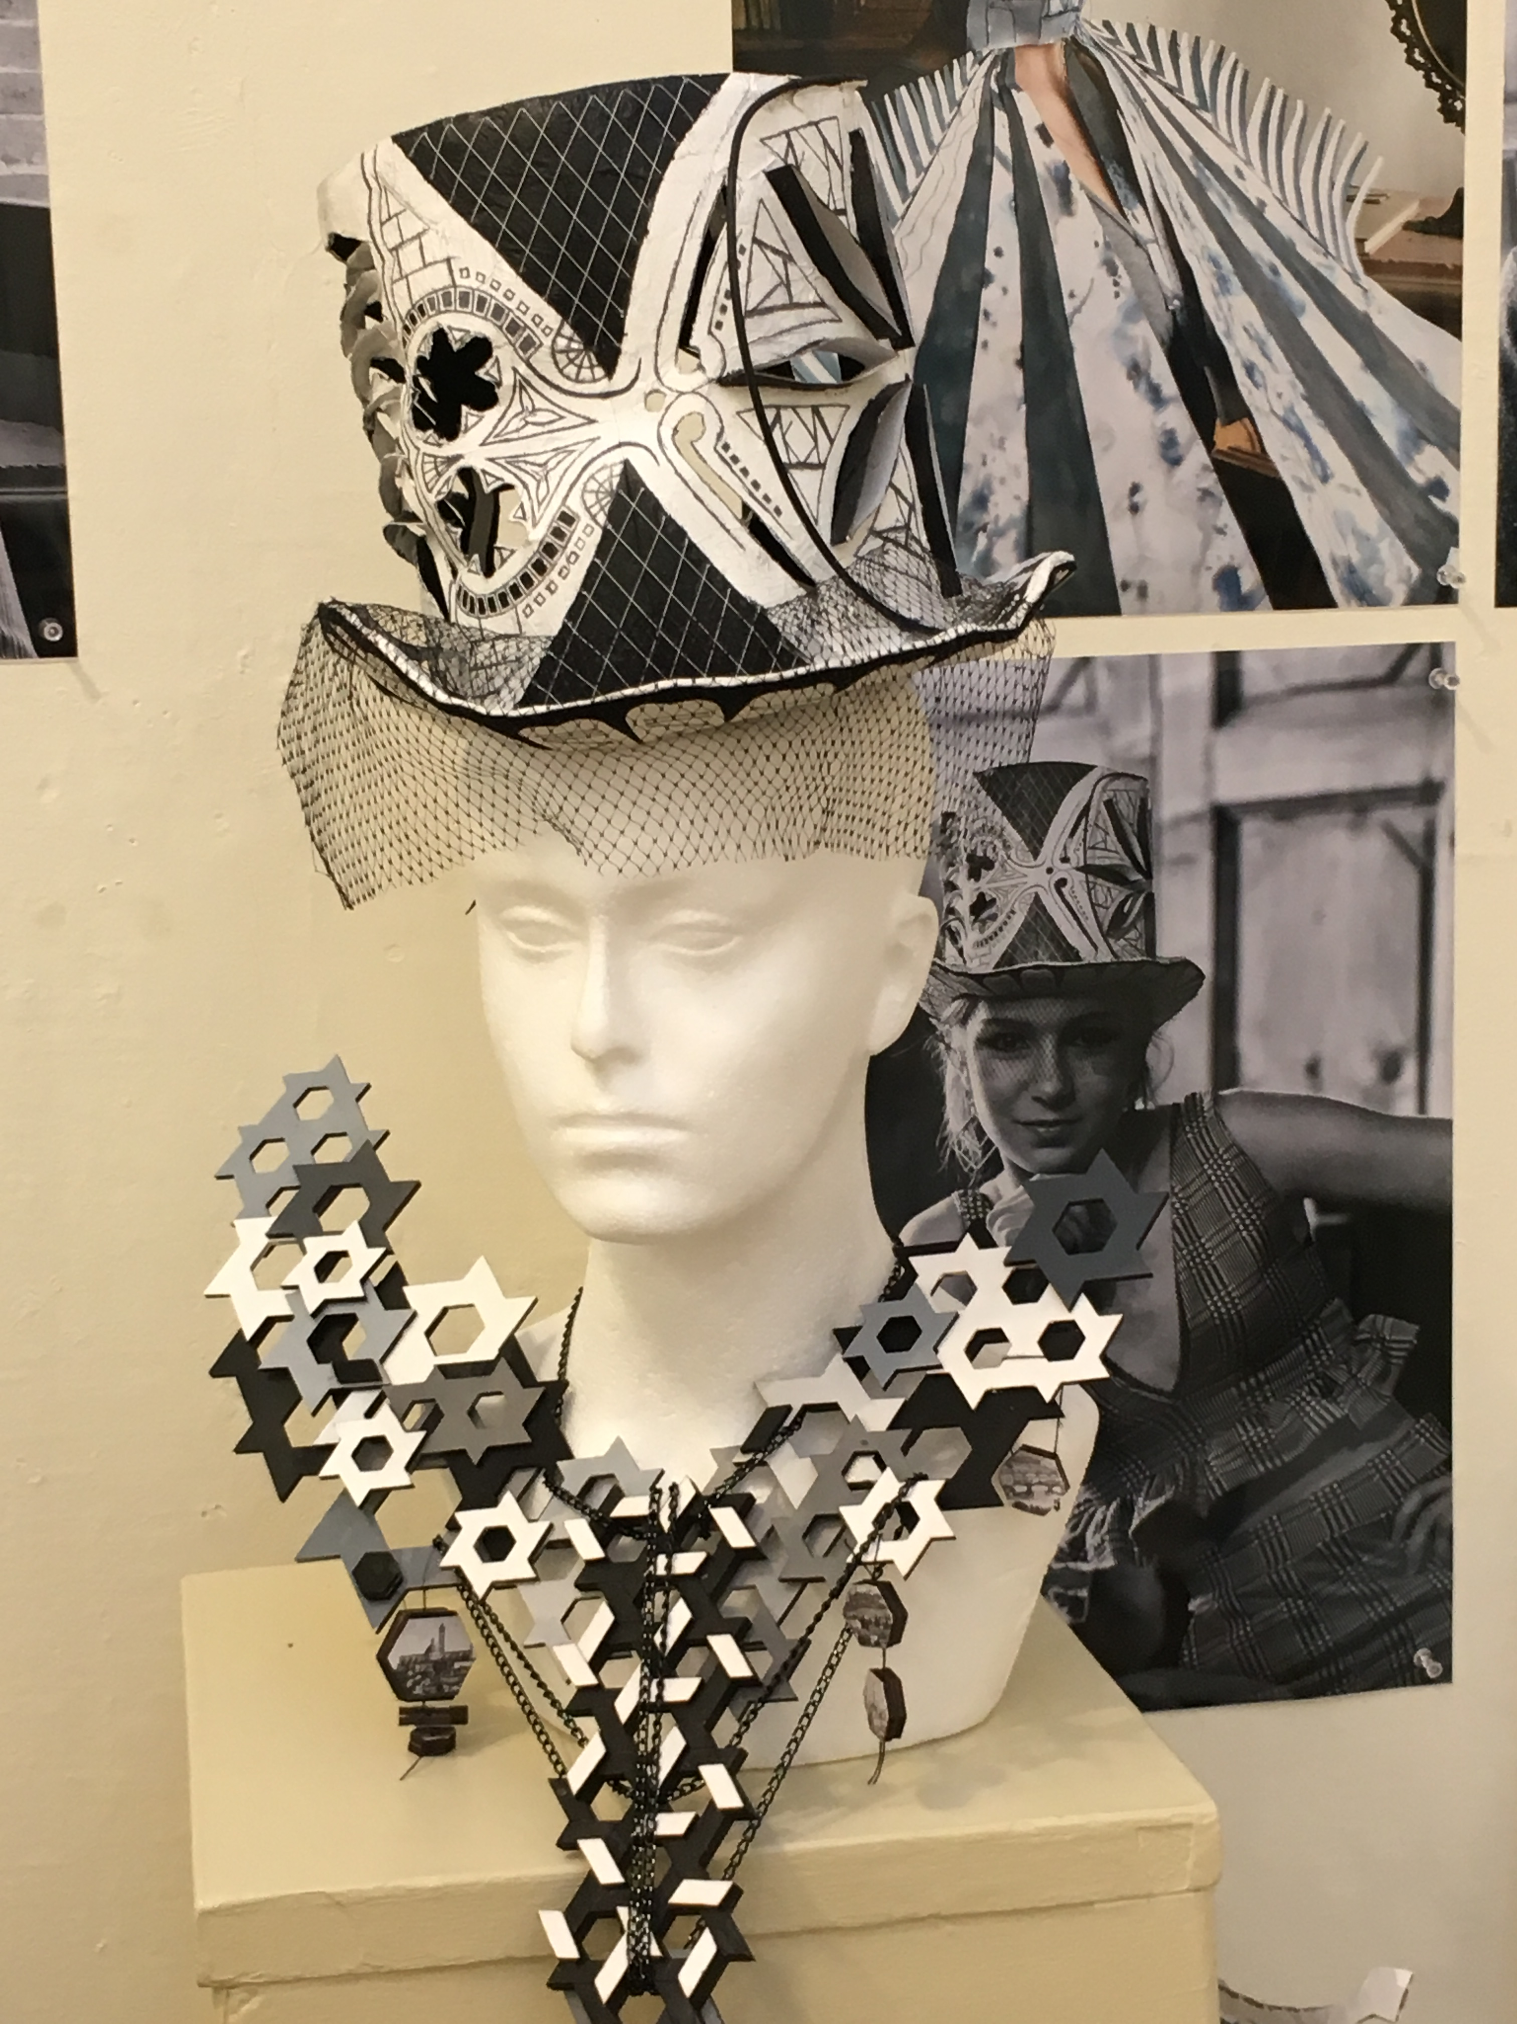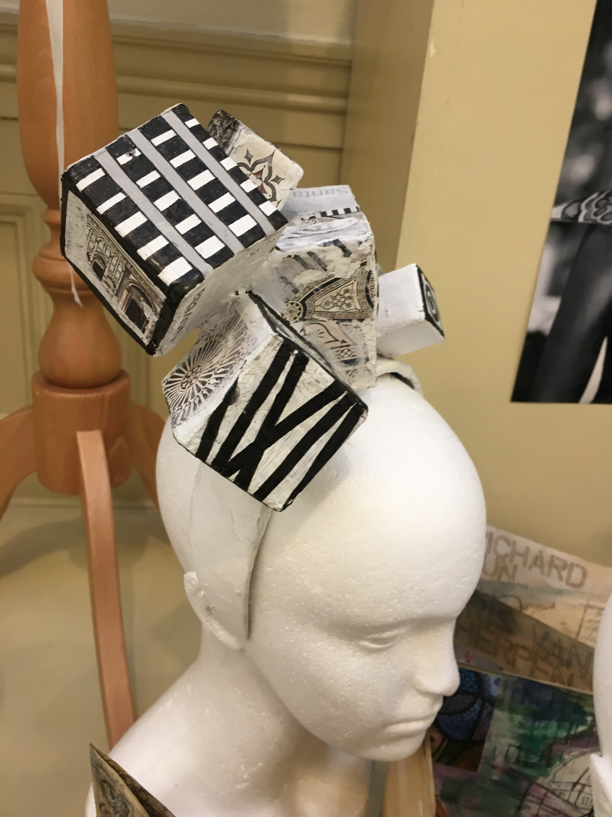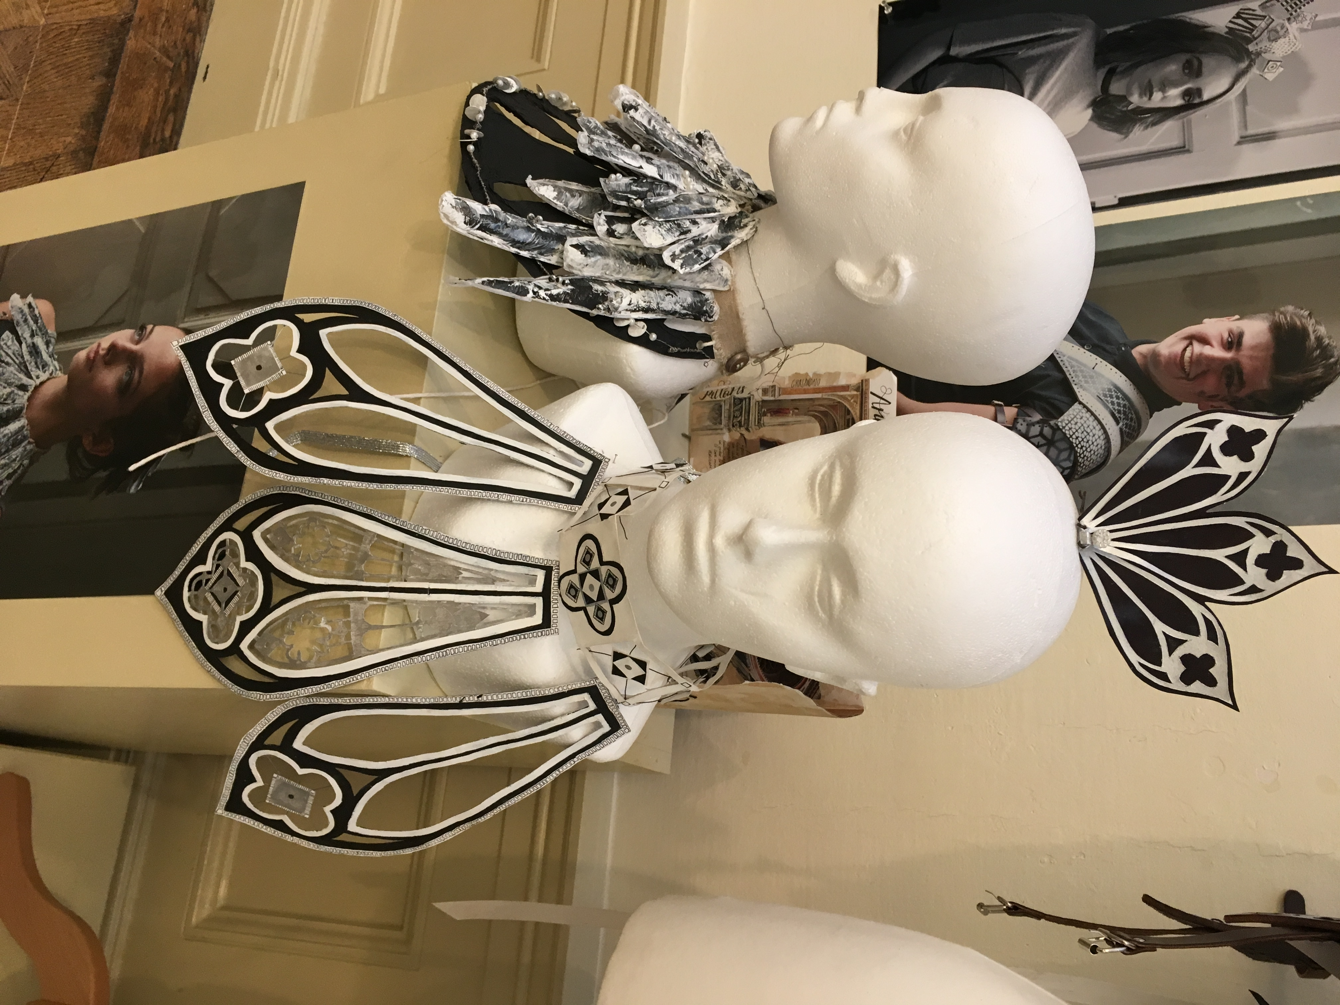

The following preparation MUST be done at home prior to the examination period and brought into school for the beginning of the exam. Failure to do this will mean that you are not properly organised to begin your exam and it will not be possible for you to make up for lost time.

Your examination is made up of 2 components:

FIRSTLY you need to produce a minimum of 10 pages of development in your sketchbook consisting of the following:
- Decorative title of your exam question
- Photographs that you have taken yourself relating to ARCHITECTURE
- Drawings from first hand observation (have the object in front of you)
- Drawings from second hand sources ie. Books, magazines, postcards etc...
- At least 3 different typed of media ie. Coloured pencil, pen & ink, paint, fabric paint etc...
- Notation about your chosen topic, what are you studying and why? Spider diagrams, bullet points only, not the life history of an artist
- Images of artists’ and designers work or culture you are studying (see list below) – your copies of their work. Try to visit an exhibition or art gallery to gather primary sources
- A minimum of 2 ideas for your final piece & a final design with Annotation
- Samples & tests for your final piece with materials, colours & techniques
- Explain how your final piece relates to your chosen artist or culture

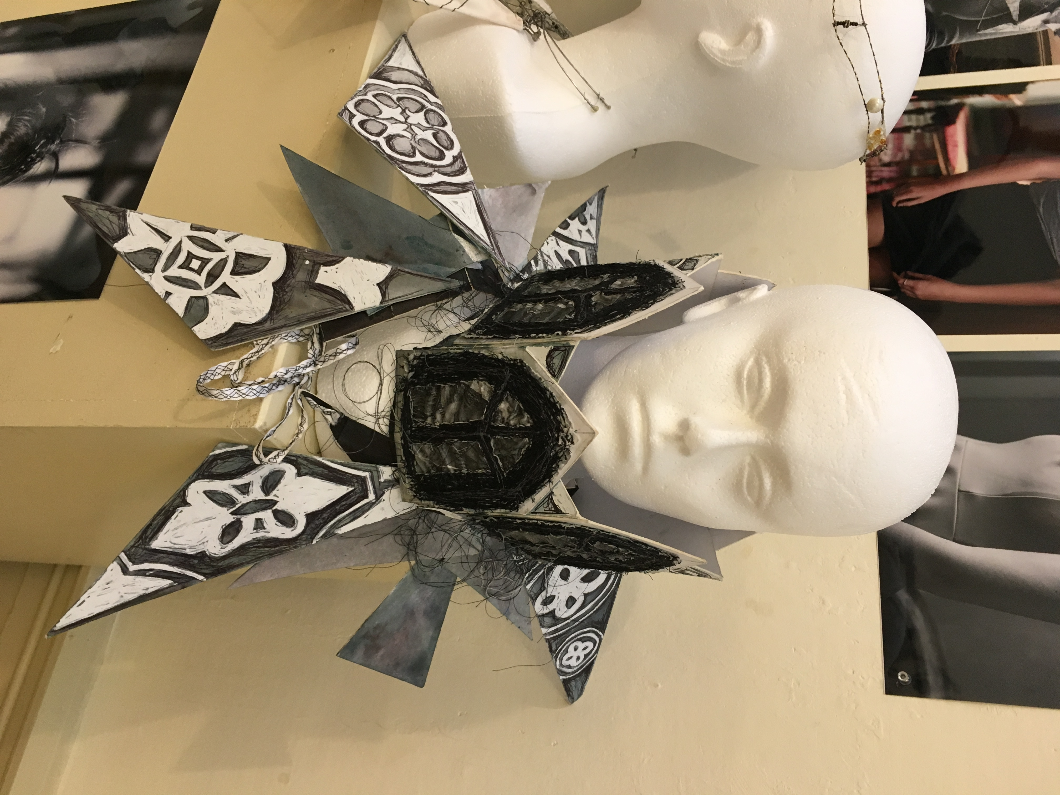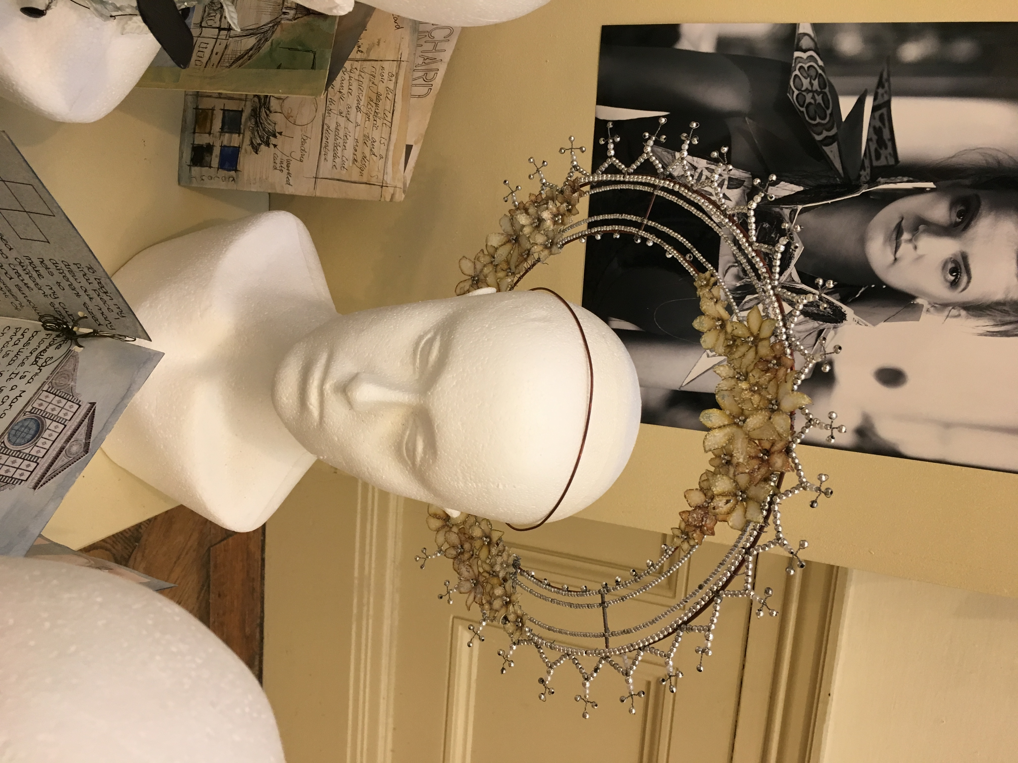

SECONDLY you will be producing your final piece of work over a 10 hour period under exam conditions. You will need to make sure that your sketchbook is completed before the examination period and brought with you to the first session. You need to make sure that you plan how you will spend the 10 hours & ensure that you have all of the materials that are needed for this.

Some examples of artists and/or cultures to look at and include in your sketchbook are:
PHILIP TREACY, NOEL STEWART, STEPHEN JONES
AFRICAN, NORTH AMERICAN INDIAN, EGYPTIAN & INDIAN HEADRESSES & JEWELLERY/BODY ADORNMENT

Your sketchbook and final piece will go towards your GCSE coursework and will count towards your final GCSE grade.
If you are unsure of what to do or need any further information please ask your Art teacher or email:
tgraham@psf.wirral.sch.uk



